Name:_____________________________________
Date:_____________
Time on Task:_____________
Make/Model/Year:____________________________________
VIN:_________________________________
Evaluation (Enter number from 4, 3, 2, 1) :_________
Meets ASE Task: : (A2-C-15) P-2 Inspect and measure planetary gear assembly components; determine needed action.

Planetary Gear Assembly Inspection
Page 448
1. Check service information for the specified procedures to follow when inspecting
planetary gear assemblies. Describe the specified procedures. _____________________
____________________________________________________________________
____________________________________________________________________
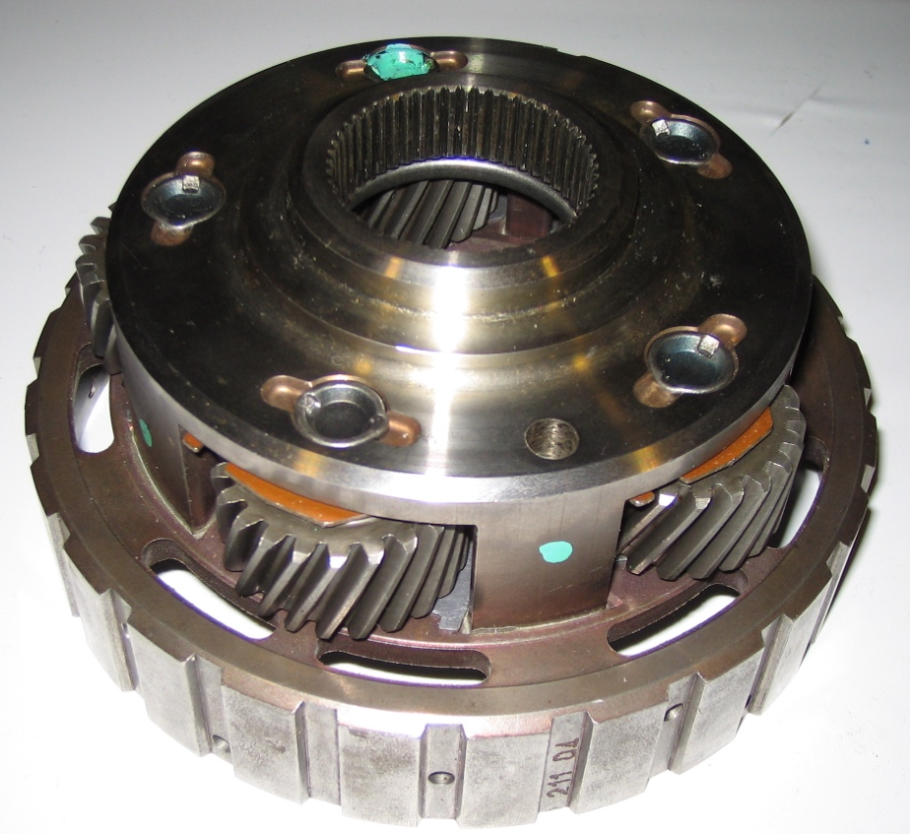

2. Based on the results of the inspection and the recommendations stated in service
information, what is the needed action? ______________________________________
___________________________________________________________________
___________________________________________________________________

