Name:_____________________________________
Date:_____________
Time on Task:_____________
Make/Model/Year:____________________________________
VIN:_________________________________
Evaluation (Enter number from 4, 3, 2, 1) :_________
Meets ASE Task: : (A2-C-14) P-2 Inspect bushings; determine needed action.

Bushing Inspection
Page 447
1. Check service information on the exact procedures to follow when inspecting bushings.
Describe the specified procedures. ___________________________________________
____________________________________________________________________
____________________________________________________________________
____________________________________________________________________
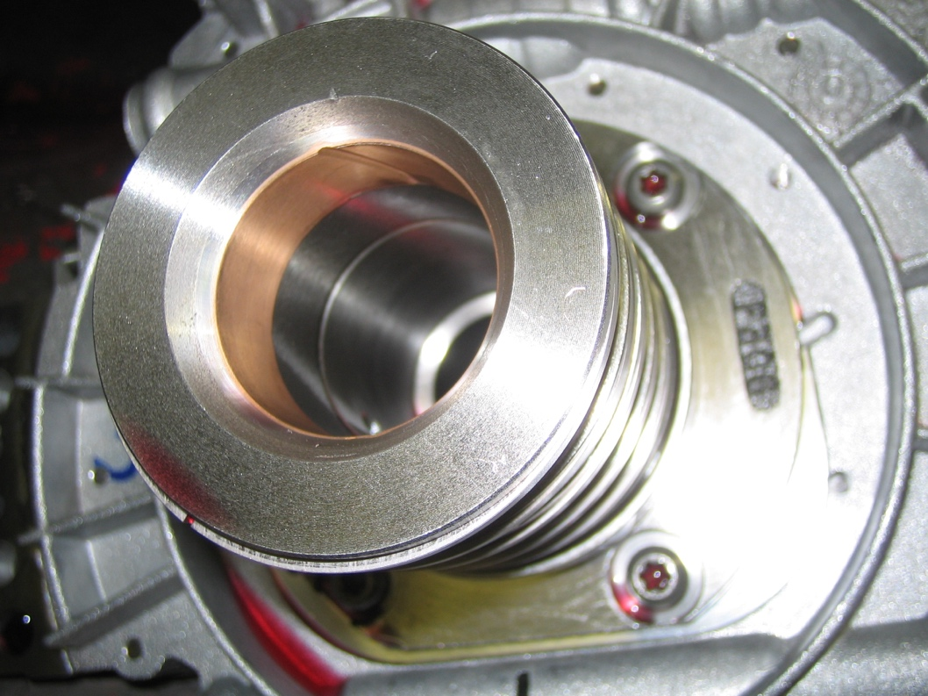

2. Based on the inspection results, what is the needed action? ______________________
___________________________________________________________________
___________________________________________________________________
___________________________________________________________________

