Name:_____________________________________
Date:_____________
Time on Task:_____________
Make/Model/Year:____________________________________
VIN:_________________________________
Evaluation (Enter number from 4, 3, 2, 1) :_________
Meets ASE Task: : (A2-C-13) P-2 Inspect oil delivery circuits, including seal rings, ring grooves, and sealing surface areas, feed pipes, orifices, and check valves/balls.

Inspect Oil Seals and Grooves
Page 446
1. Check service information and determine the specified procedures to follow when
inspecting oil seals and grooves. Describe the specified procedures. ________________
____________________________________________________________________
____________________________________________________________________
____________________________________________________________________
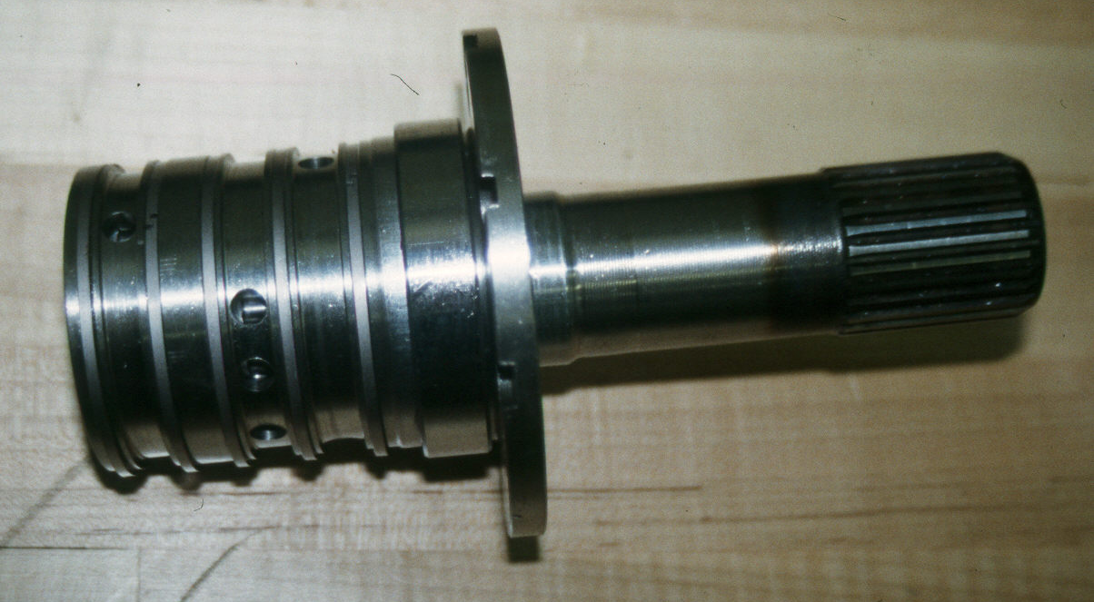

2. Based on the inspection, what is the needed action? _____________________________
____________________________________________________________________
____________________________________________________________________
____________________________________________________________________

