Name:_____________________________________
Date:_____________
Time on Task:_____________
Make/Model/Year:____________________________________
VIN:_________________________________
Evaluation (Enter number from 4, 3, 2, 1) :_________
Meets ASE Task: : (A2-C-12) P-2 Inspect, measure, and/or replace thrust washers and bearings.

Thrust Washer and Bearing Inspection
Page 445
1. Check service information and determine the exact procedures to follow when inspecting
thrust washers and bearings. Describe the specified procedures. ___________________
____________________________________________________________________
____________________________________________________________________
____________________________________________________________________
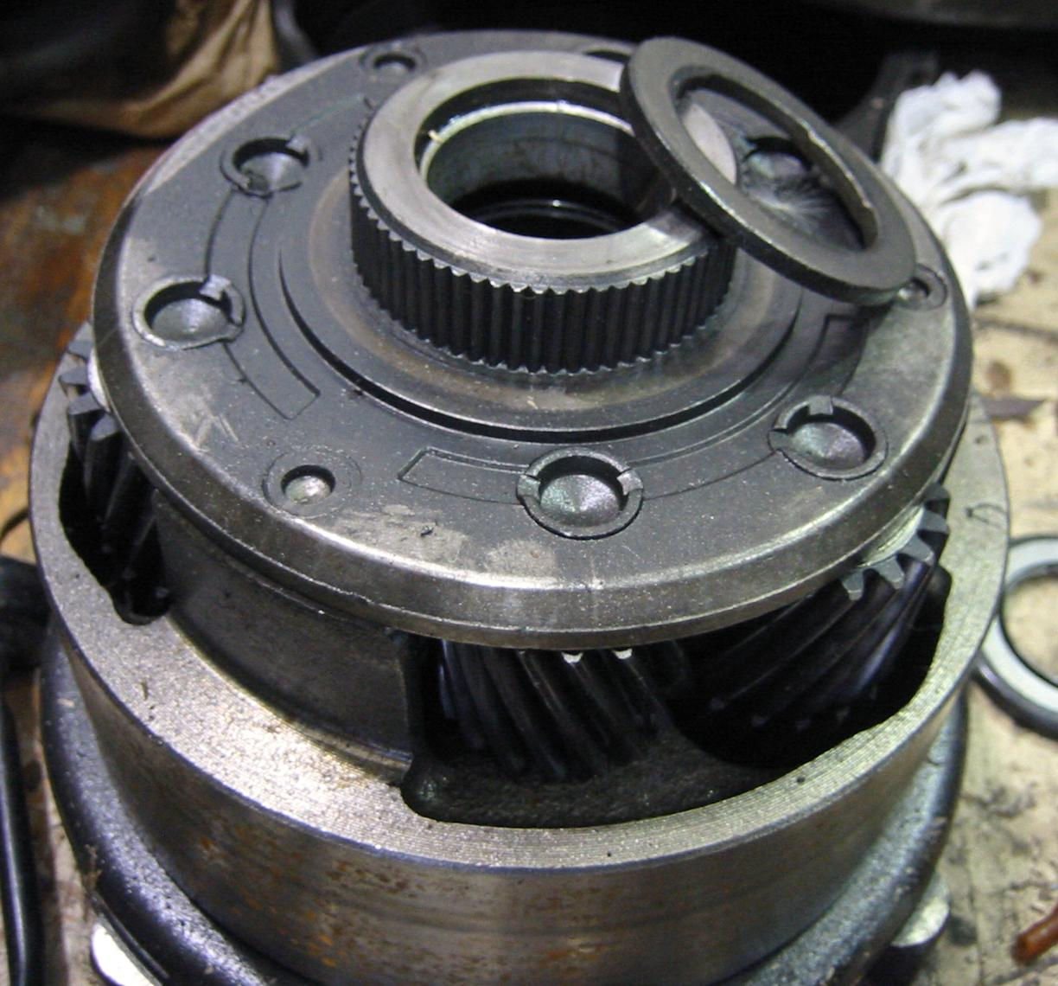

2. According to the specified test results, did any bearings or thrust washers require
replacement? No Yes If yes, describe the fault that required replacement.
____________________________________________________________________
____________________________________________________________________

