Name:_____________________________________
Date:_____________
Time on Task:_____________
Make/Model/Year:____________________________________
VIN:_________________________________
Evaluation (Enter number from 4, 3, 2, 1) :_________
Meets ASE Task: : (A2-C-11) P-1 Measure transmission/transaxle end play or preload; determine needed action.

Endplay/Preload Measurement
Page 444
1. Check service information for the exact procedures to follow when measuring
endplay/preload. Describe the specified procedures. ____________________________
____________________________________________________________________
____________________________________________________________________
____________________________________________________________________
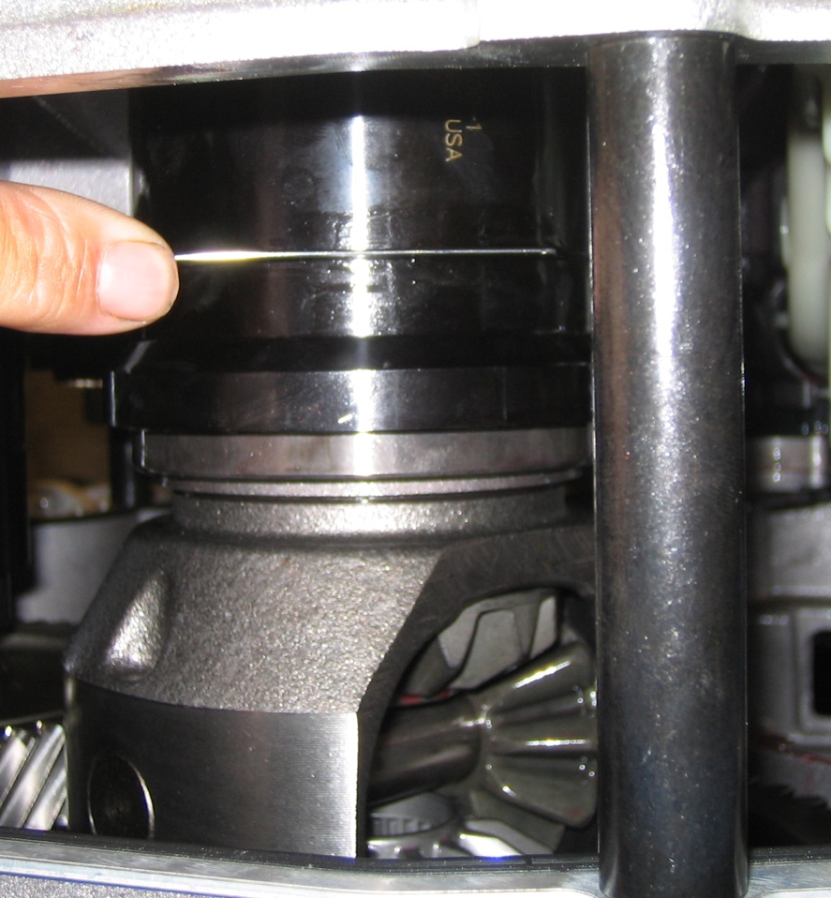

2. Based on the measurement results, what is the needed action? ___________________
__________________________________________________________________

