Name:_____________________________________
Date:_____________
Time on Task:_____________
Make/Model/Year:____________________________________
VIN:_________________________________
Evaluation (Enter number from 4, 3, 2, 1) :_________
Meets ASE Task: (A2-C-10) P-2 Inspect, measure, and reseal oil pump assembly and components.

Inspect Oil Pump Assembly
Page 443
1. Check service information for the specified procedure to follow when inspecting the oil
pump assembly. Describe the inspection procedures. ____________________________
____________________________________________________________________
____________________________________________________________________
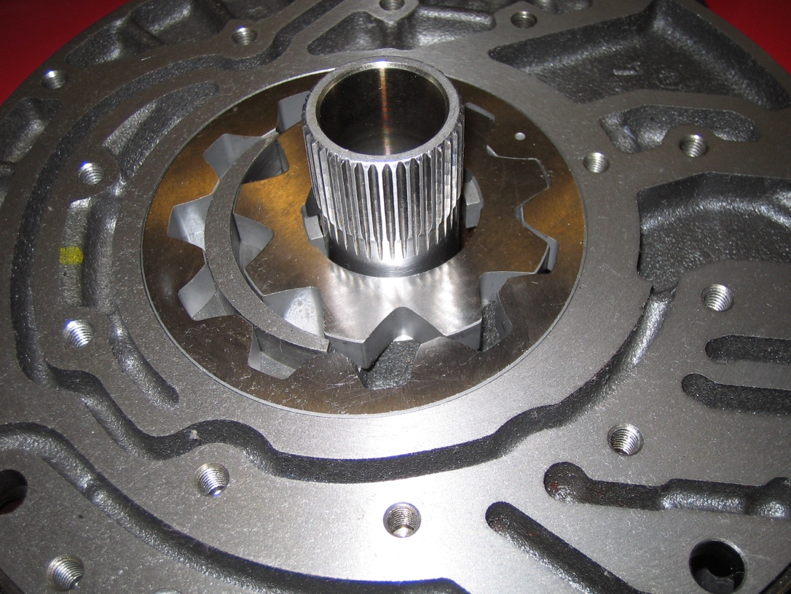
____________________________________________________________________

2. According to the results of the inspection, should the oil pump assembly be replaced?
No Yes If yes, explain the reason. ____________________________
___________________________________________________________________
___________________________________________________________________
___________________________________________________________________

