Name:_____________________________________
Date:_____________
Time on Task:_____________
Make/Model/Year:____________________________________
VIN:_________________________________
Evaluation (Enter number from 4, 3, 2, 1) :_________
Meets ASE Task: (A2-C-3) P-2 Remove and reinstall transmission/transaxle and torque converter; inspect engine core plugs, rear crankshaft seal, dowel pins, dowel pin holes, and mating surfaces.

Install Torque Converter
Page 442
1. Check service information and determine the specified procedures to follow when
inspecting a torque converter. Describe the specified procedures. __________________
____________________________________________________________________
____________________________________________________________________
____________________________________________________________________
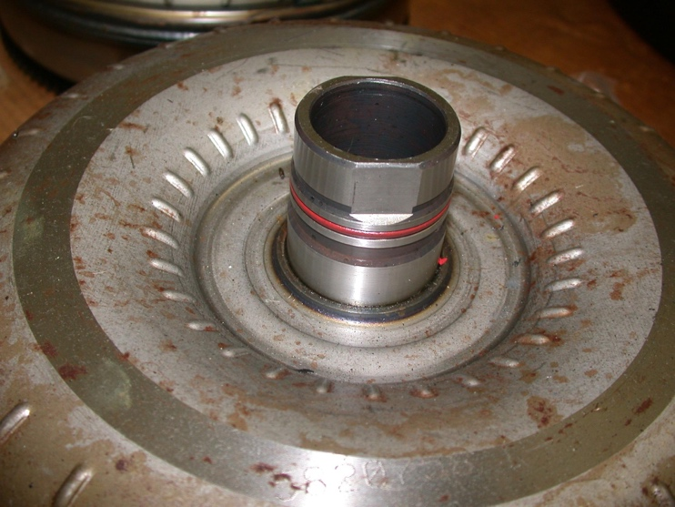

2. According to service information, how is the stator checked? _____________________
___________________________________________________________________
___________________________________________________________________
3. According to the test results, doe the torque converter require replacement?
No Yes If yes, describe why. _______________________________
___________________________________________________________________
___________________________________________________________________

