Name:_____________________________________
Date:_____________
Time on Task:_____________
Make/Model/Year:____________________________________
VIN:_________________________________
Evaluation (Enter number from 4, 3, 2, 1) :_________
Meets ASE Task: (A2-C-5) P-2 Inspect converter flex (drive) plate, converter attaching bolts, converter pilot, converter pump drive surfaces, converter end play, and crankshaft pilot bore.

Inspect Converter Flex Plate
Page 441
1. Check service information for the specified procedures to follow when inspecting the
converter flex plate. Describe the specified procedures. __________________________
____________________________________________________________________
____________________________________________________________________
____________________________________________________________________
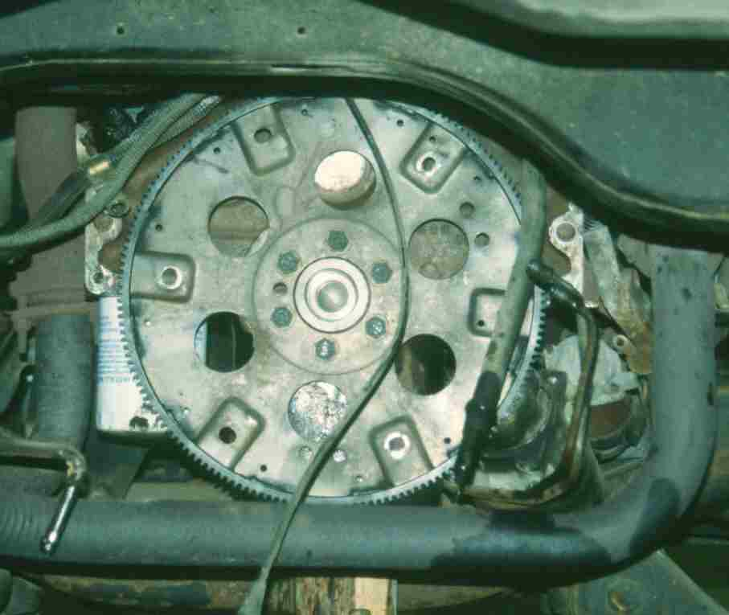

2. Based on the results of the inspection, does the flex
plate require replacement?
No Yes Describe the reasons. ________________________________
____________________________________________________________________

