Name:_____________________________________
Date:_____________
Time on Task:_____________
Make/Model/Year:____________________________________
VIN:_________________________________
Evaluation (Enter number from 4, 3, 2, 1) :_________
Meets ASE Task: (A2-C-4) P-1 Inspect, leak test, flush and/or replace transmission/transaxle oil cooler, lines, and fittings.
Flush Cooler Lines
Page 440
1. Check service information for the specified procedures to follow when flushing cooler
lines. Describe the specified procedures. _____________________________________
____________________________________________________________________
____________________________________________________________________
____________________________________________________________________
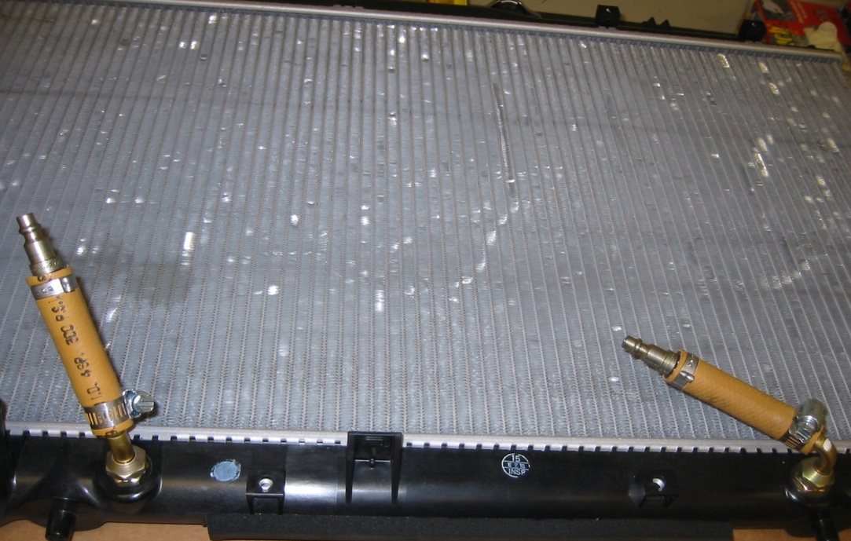

2. According to service information, how many quarts (liters) of ATF should flow through
the cooler? _______________________

