Evaluation (Enter number from 4, 3, 2, 1) :_________
Meets ASE Task: (A1-A-1) P-1 Research vehicle service information such as fluid type, internal combustion engine operation, vehicle service history, service precautions, technical service bulletins, and recalls including vehicles equipped with advanced driver assistance systems (ADAS).

General Engine Specification

Name:_____________________________________
Date:_____________
Time on Task:_____________
Make/Model/Year:____________________________________
VIN:_________________________________
Page 44
1. Engine type (V-6, V-8, etc.) = ______________________

2. Bore = _________________
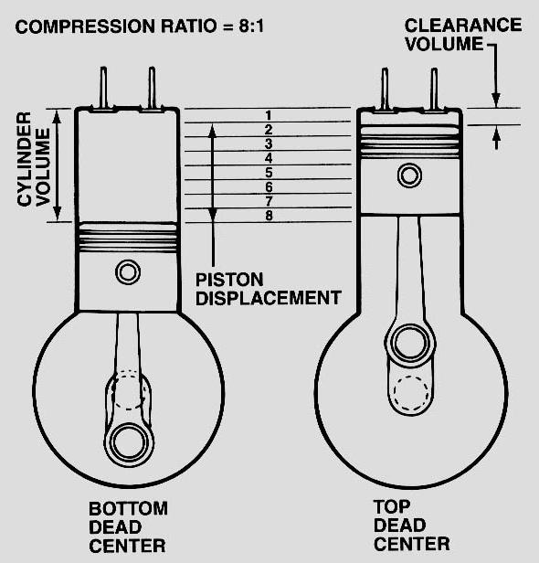
3. Stroke = _________________

4. Compression ratio = ________________

5. Displacement: cubic inches = __________

cc = __________ liter = _________

6. Horsepower = ___________ @ _______RPM

7. Torque = ____________ @ _______RPM

8. Firing order = ________________________

9. Engine oil capacity = _________________

10. Cylinder block material = __________________________

11. Crankshaft material (forged steel, cast iron) = ___________________________

12. Cylinder head material = ______________________________

13. Connecting rod material (forged steel, powdered metal, etc.) = __________________

