Name:_____________________________________
Date:_____________
Time on Task:_____________
Make/Model/Year:____________________________________
VIN:_________________________________
Evaluation (Enter number from 4, 3, 2, 1) :_________
Meets ASE Task: (A2-C-9) P-2 Assemble automatic transmission/transaxle.
Assemble Automatic Transmission/Transaxle
Page 439
1. Check service information for the recommended procedures for assembling the specific
automatic transmission/transaxle being service. Summarize the specified procedures.
____________________________________________________________________
____________________________________________________________________
____________________________________________________________________
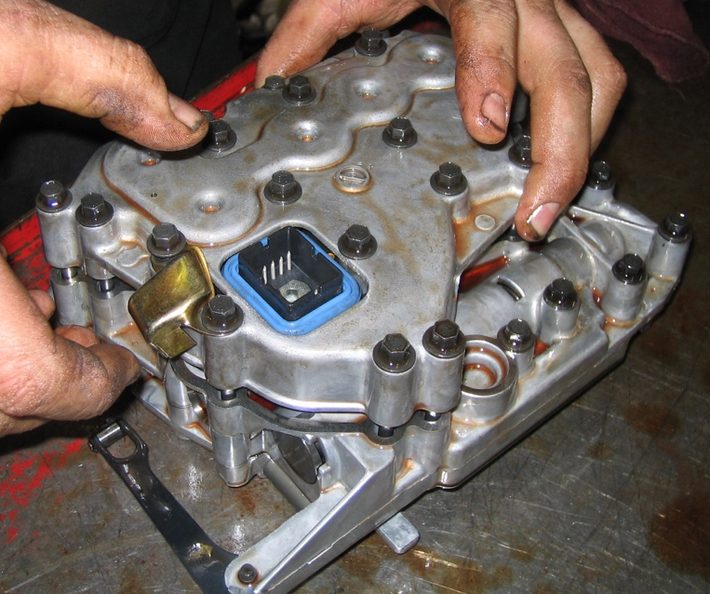
____________________________________________________________________

2. List the torque specifications of all fasteners.
Fastener (description) Specified Torque
_______________________________ _________________________
_______________________________ _________________________
_______________________________ _________________________
_______________________________ _________________________
_______________________________ _________________________

