Name:_____________________________________
Date:_____________
Time on Task:_____________
Make/Model/Year:____________________________________
VIN:_________________________________
Evaluation (Enter number from 4, 3, 2, 1) :_________
Meets ASE Task: (A2-C-8) P-2 Inspect servo and accumulator bores, pistons, seals, pins, springs, and retainers; determine needed action.
Inspect Servo Bore, Piston, and Seals
Page 438
1. Check service information for the recommended procedures to follow when inspecting
servo bore, pistons, and seals. Describe the recommended procedures. ______________
____________________________________________________________________
____________________________________________________________________
____________________________________________________________________
____________________________________________________________________
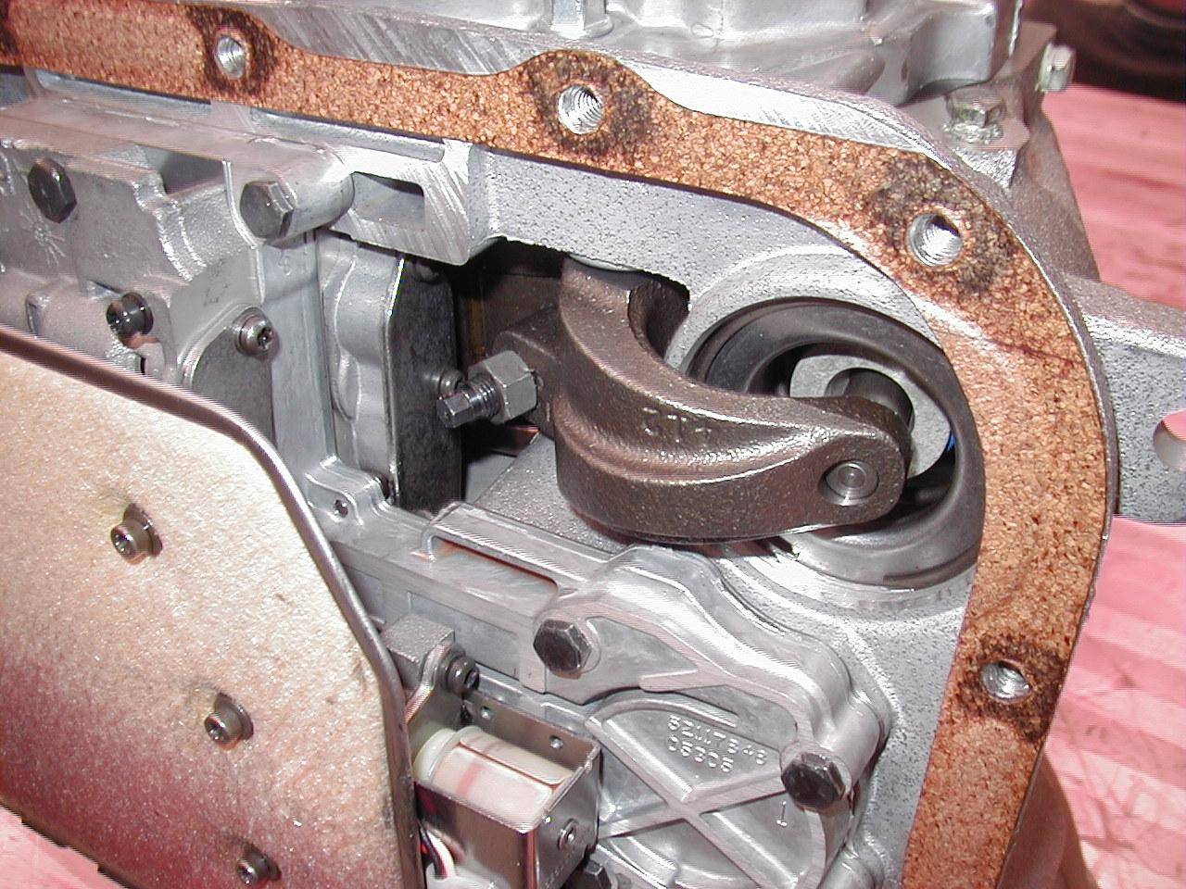

2. Based on the inspection results, what is the needed action? _______________________
____________________________________________________________________ ____________________________________________________________________
____________________________________________________________________
____________________________________________________________________

