Name:_____________________________________
Date:_____________
Time on Task:_____________
Make/Model/Year:____________________________________
VIN:_________________________________
Evaluation (Enter number from 4, 3, 2, 1) :_________
Meets ASE Task: (A2-C-7) P-2 Inspect, measure, clean, and replace valve body (includes surfaces, bores, springs, valves, switches, solenoids, sleeves, retainers, brackets, check valves/balls, screens, spacers, and gaskets).

Inspect and Service Valve Body Assembly
Page 437
1. Check service information for the recommended procedures to follow for inspecting and
servicing valve body parts. Describe the recommended procedure. _________________
____________________________________________________________________
____________________________________________________________________
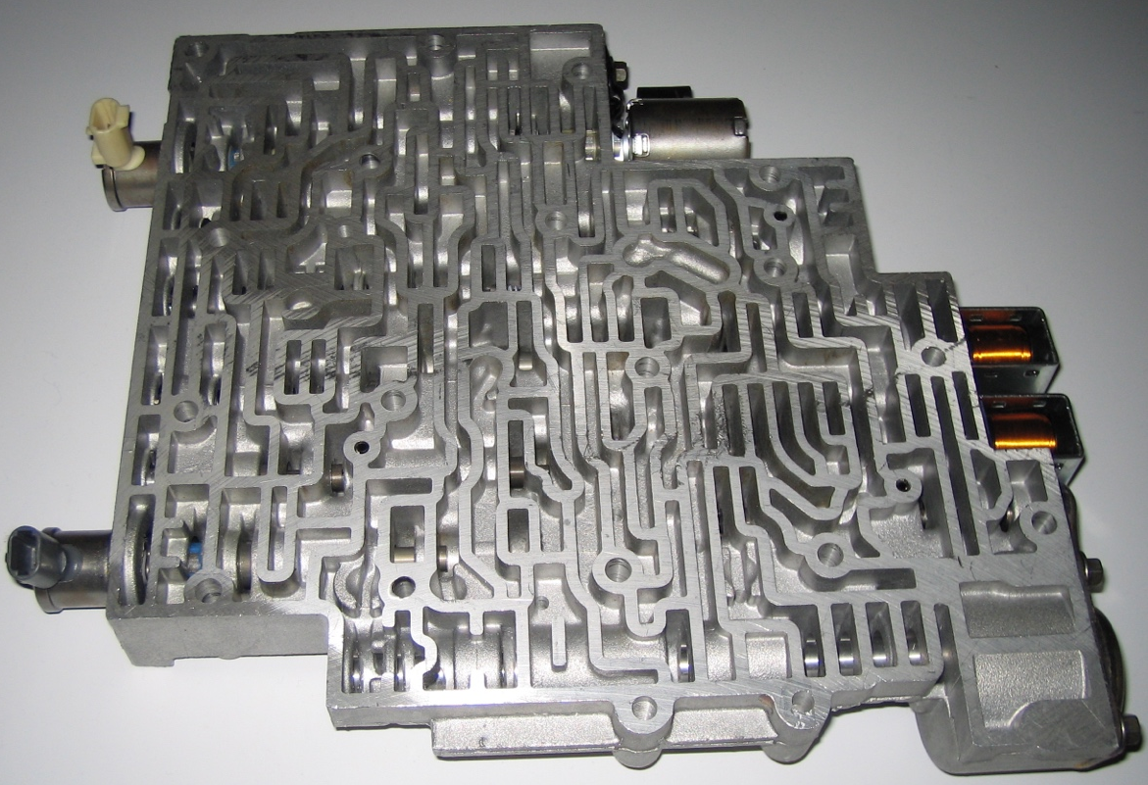

2. List all cautions and warnings, including only use lint free cloths when servicing a valve
body. List all that pertain. _________________________________________________
____________________________________________________________________
____________________________________________________________________
____________________________________________________________________

