Name:_____________________________________
Date:_____________
Time on Task:_____________
Make/Model/Year:____________________________________
VIN:_________________________________
Evaluation (Enter number from 4, 3, 2, 1) :_________
Meets ASE Task: (A2-C-6) P-2 Disassemble, clean, and inspect transmission/transaxle.

Disassemble Auto Transmission/Transaxle
Page 436
1. Check service information for the recommended procedures to follow when
disassembling an automatic transmission/transaxle. Summarize the recommended
disassembly procedures. ___________________________________________________
____________________________________________________________________
____________________________________________________________________ ____________________________________________________________________
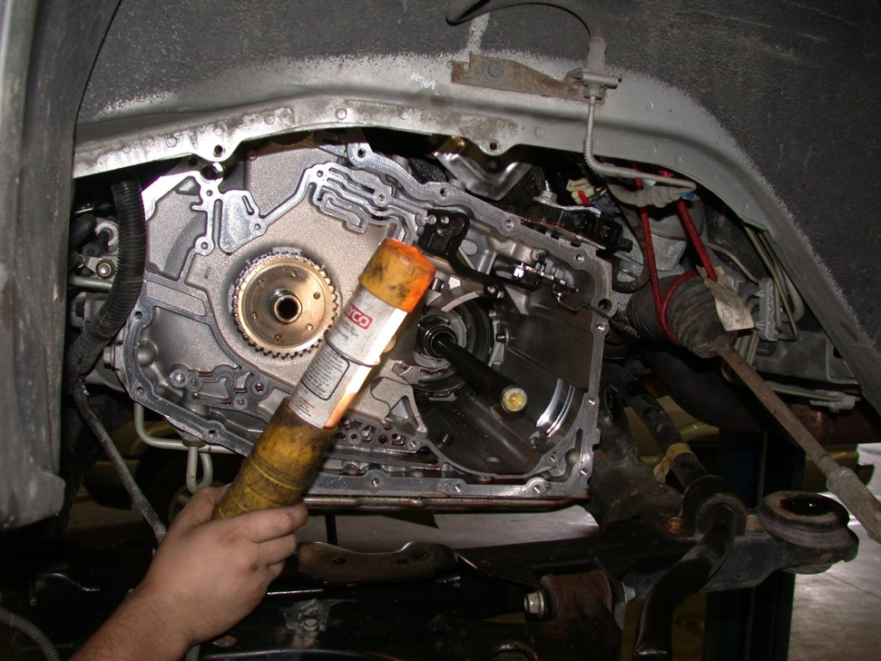

2. Check service information and determine the recommended parts cleaning chemicals and
procedures to use. ________________________________________________________
____________________________________________________________________
____________________________________________________________________
____________________________________________________________________

