Name:_____________________________________
Date:_____________
Time on Task:_____________
Make/Model/Year:____________________________________
VIN:_________________________________
Evaluation (Enter number from 4, 3, 2, 1) :_________
Meets ASE Task: (A2-C-3) P-2 Remove and reinstall transmission/transaxle and torque converter; inspect engine core plugs, rear crankshaft seal, dowel pins, dowel pin holes, and mating surfaces.

Remove/Install Auto Transmission/Transaxle
Page 435
1. Check service information for the specified procedures for removing and reinstalling an
automatic transmission/transaxle. Summarize the recommended procedures.
____________________________________________________________________
____________________________________________________________________
____________________________________________________________________
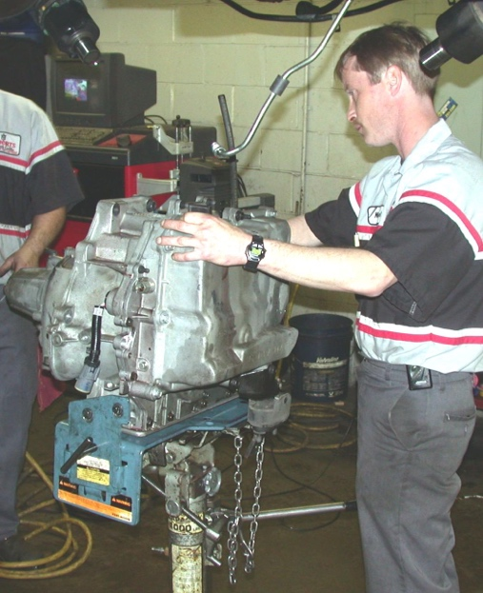

2. List the torque specifications of all fasteners.
Fastener (description) Specified Torque
_______________________________ _________________________
_______________________________ _________________________
_______________________________ _________________________
_______________________________ _________________________
_______________________________ _________________________

