Name:_____________________________________
Date:_____________
Time on Task:_____________
Make/Model/Year:____________________________________
VIN:_________________________________
Evaluation (Enter number from 4, 3, 2, 1) :_________
Meets ASE Task: (A2-B-5) P-2 Inspect for leakage; replace external seals, gaskets, and bushings.
Replace Seals and Gaskets
Page 434
1. Check service information and determine the specified methods and procedures to follow
when replacing seals and gaskets. Describe the recommended procedures. ___________
____________________________________________________________________
____________________________________________________________________
____________________________________________________________________
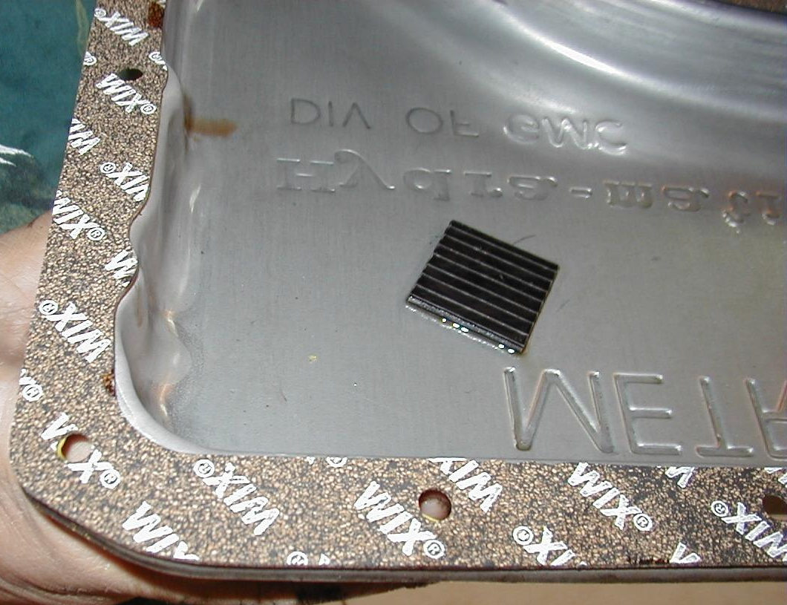

2. List the gaskets and/or seals inspected or replaced.
a. ________________________ c. __________________________
b. ________________________ d. __________________________

