Name:_____________________________________
Date:_____________
Time on Task:_____________
Make/Model/Year:____________________________________
VIN:_________________________________
Evaluation (Enter number from 4, 3, 2, 1) :_________
Meets ASE Task: (A2-A-3) P-1 Retrieve and record DTCs, OBD monitor status, and freeze frame data; clear codes and data when directed.

Electronic Transmission Scan Tool Diagnosis
Page 432
1. Check service information for the exact procedures and equipment needed to identify
and diagnose electronic transmission control systems using a scan tool (describe). _____
____________________________________________________________________
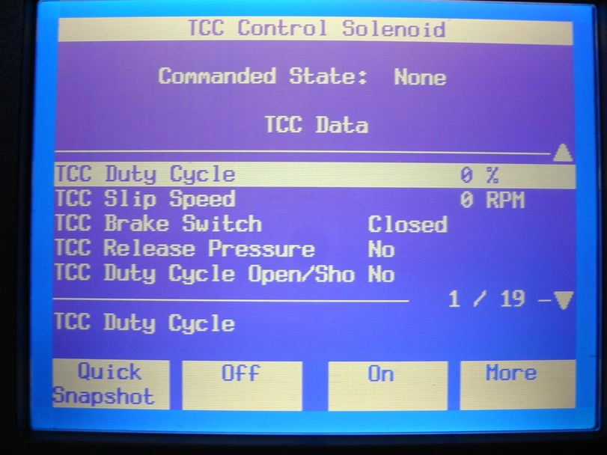
____________________________________________________________________

2. What is the designated scan
tool to be used? _____________
___________________________
___________________________
___________________________
___________________________
3. What was the result of the scan
tool diagnosis? ______________
___________________________
_______________________________________________________________________
_______________________________________________________________________
4. List all transmission-related diagnostic trouble codes.
Code (DTC) Meaning of DTC
a. ____________________________ ________________________________
b. ____________________________ ________________________________
c. ____________________________ ________________________________
d. ____________________________ ________________________________

