Name:_____________________________________
Date:_____________
Time on Task:_____________
Make/Model/Year:____________________________________
VIN:_________________________________
Evaluation (Enter number from 4, 3, 2, 1) :_________
Meets ASE Task: (A2-B-1) P-1 Inspect, adjust, and/or replace external manual valve shift linkage, transmission range sensor/switch, and/or park/neutral position switch.

Inspect and Adjust Linkages
Page 431
1. Check service information for the specified method to follow to adjust linkages and
cables. Describe the recommended procedure. __________________________________
____________________________________________________________________
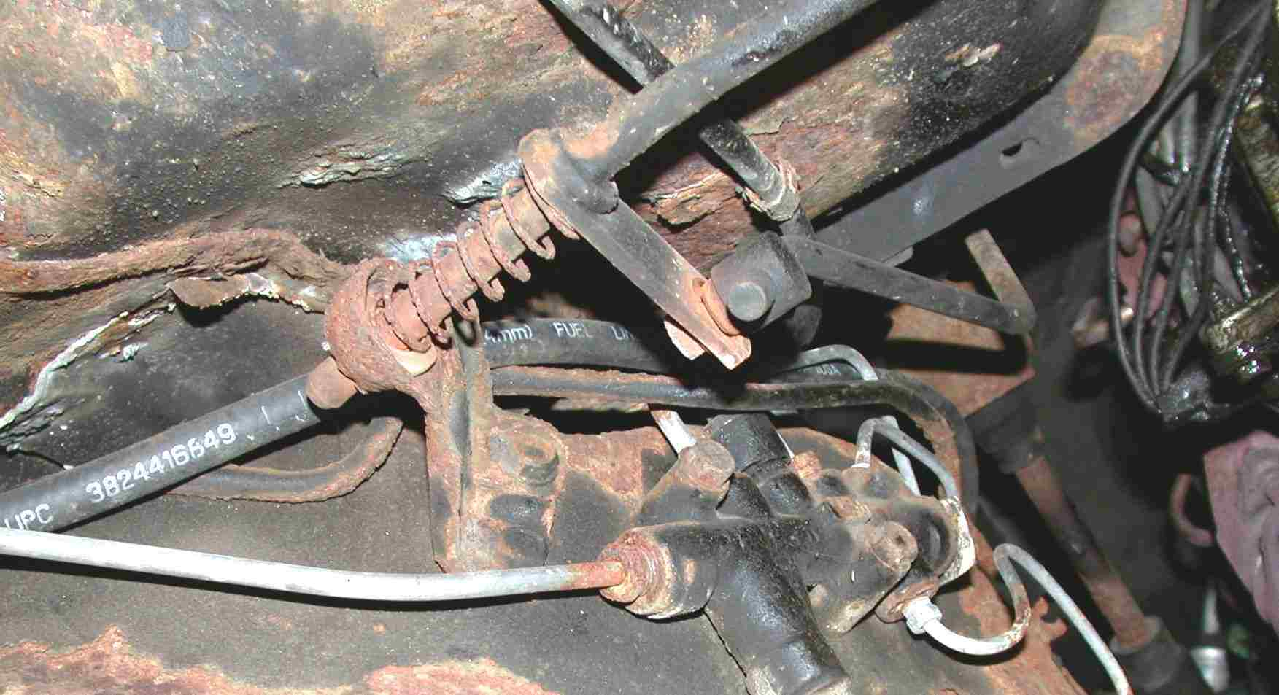
____________________________________________________________________

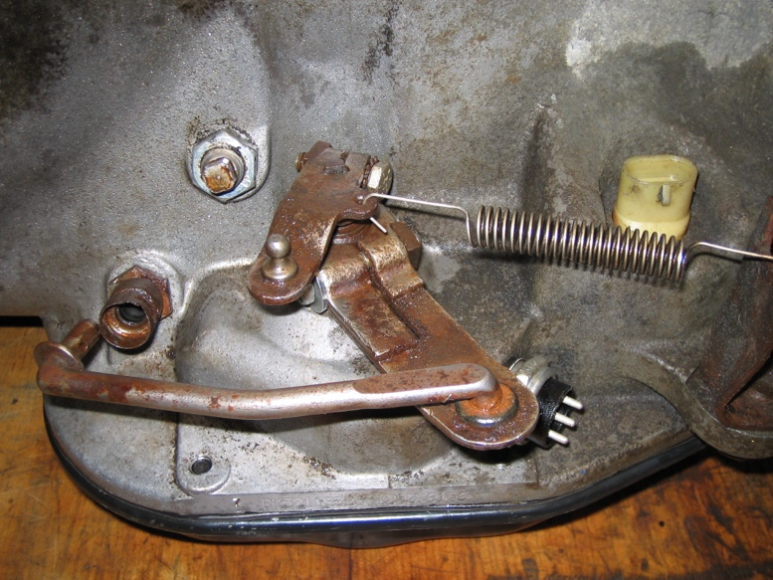
2. Describe the results of the inspection.
____________________________
____________________________
____________________________
3. Was a linkage adjustment needed?
Yes No
If yes (describe) ______________
____________________________
____________________________

