Name:_____________________________________
Date:_____________
Time on Task:_____________
Make/Model/Year:____________________________________
VIN:_________________________________
Evaluation (Enter number from 4, 3, 2, 1) :_________
Meets ASE Task: (A2-A-13) P-1 Diagnose electronic transmission/transaxle control systems using appropriate test equipment and service information. (A2-B-6) P-1 Inspect, test, adjust, repair, and/or replace electrical/electronic components and circuits.

Diagnose Electrical/Electronic Concerns
Page 430
1. Check service information and determine the specified tests and procedures to follow
when diagnosing electrical/electronic concerns. Describe specified procedures. _______
____________________________________________________________________
____________________________________________________________________
____________________________________________________________________
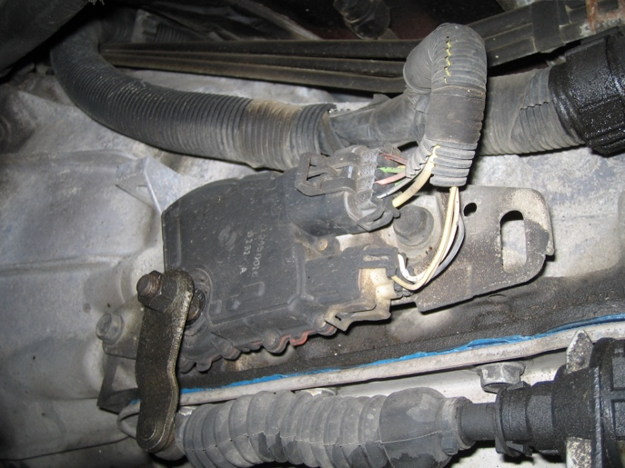
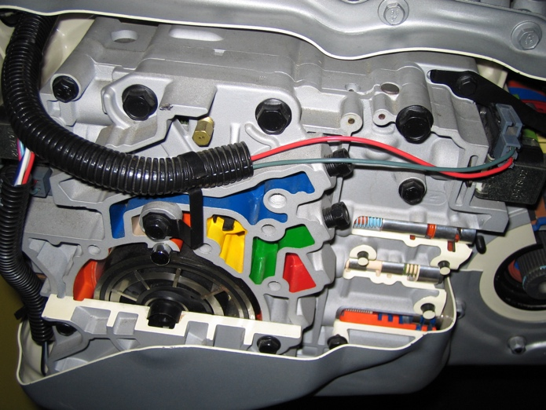

2. What tools/test equipment is specified to be used during the diagnosis of
electrical/electronic concerns? Check all that apply.
Scan tool
DMM
Special tester (describe) __________________________________________
Other (Describe) ________________________________________________

