Evaluation (Enter number from 4, 3, 2, 1) :_________
Meets ASE Task: (A1-A-1) P-1 Research vehicle service information such as fluid type, internal combustion engine operation, vehicle service history, service precautions, technical service bulletins, and recalls including vehicles equipped with advanced driver assistance systems (ADAS).

Gasoline Engine Identification

Name:_____________________________________
Date:_____________
Time on Task:_____________
Make/Model/Year:____________________________________
VIN:_________________________________
Page 43
1. Number of cylinders = ________ Arrangement of cylinders = _________________
2. Number and arrangement of camshafts = ___________________________________
3. Bore = ________ Stroke = _______ Cu. in. = ______ cc = ______ Liters = ______
4. Rated HP = ________ @ RPM _______
5. Rated torque = _________ @ RPM _______
6. Compression ratio = _______________
7. Recommended octane of gasoline required = ______________________
8. The block is constructed of: cast iron aluminum
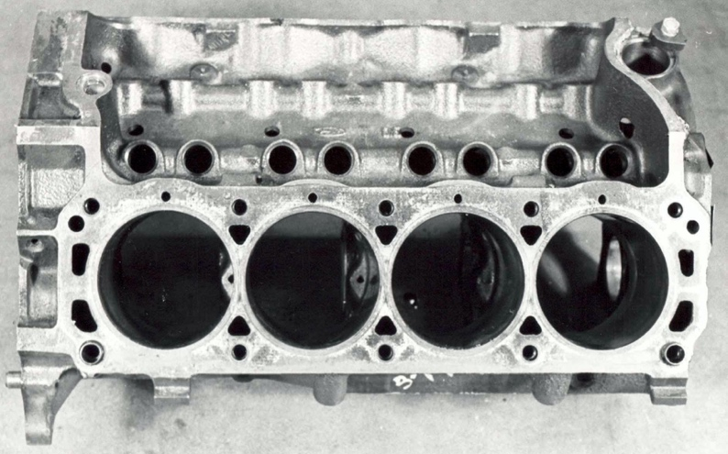

9. Cylinder head(s) is constructed of: cast iron aluminum
10. Intake manifold is: one piece two pieces (upper and lower) and is
constructed of: cast iron aluminum composite

