Name:_____________________________________
Date:_____________
Time on Task:_____________
Make/Model/Year:____________________________________
VIN:_________________________________
Evaluation (Enter number from 4, 3, 2, 1) :_________
Meets ASE Task: (A2-A-14) P-2 Diagnose noise and vibration concerns; determine needed action.

Noise and Vibration Diagnosis
Page 429
1. Check service information and determine the specified methods and procedures to follow
when diagnosing noise and vibration concerns. Describe the procedures. ____________
____________________________________________________________________
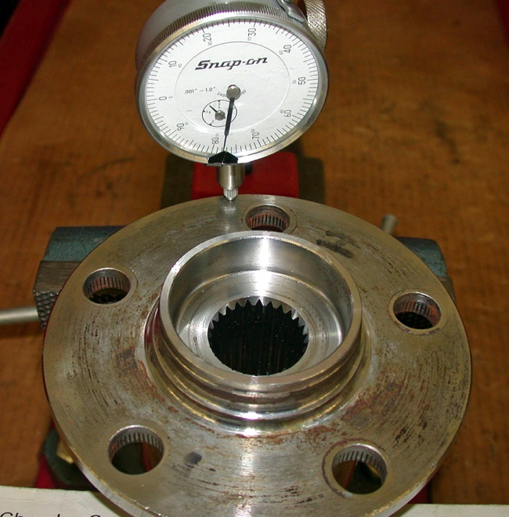
____________________________________________________________________

2. What test equipment was specified? Check all that apply.
Scan tool
Vibration analyzer
Noise diagnostic tester
Other (describe) ________________________________________________
3. Based on the tests and inspection, what is the needed action? ______________________
____________________________________________________________________
____________________________________________________________________

