Name:_____________________________________
Date:_____________
Time on Task:_____________
Make/Model/Year:____________________________________
VIN:_________________________________
Evaluation (Enter number from 4, 3, 2, 1) :_________
Meets ASE Task: (A2-A-10) P-2 Perform stall test; determine needed action.
Torque Converter Stall Test
Page 427
CAUTION: Many vehicle manufacturers do not recommend perform this test.

1. Check service information and determine if a stall test is recommended and is so, how to
perform it without harming the transmission/transaxle. Describe the recommended
procedures. _____________________________________________________________
____________________________________________________________________
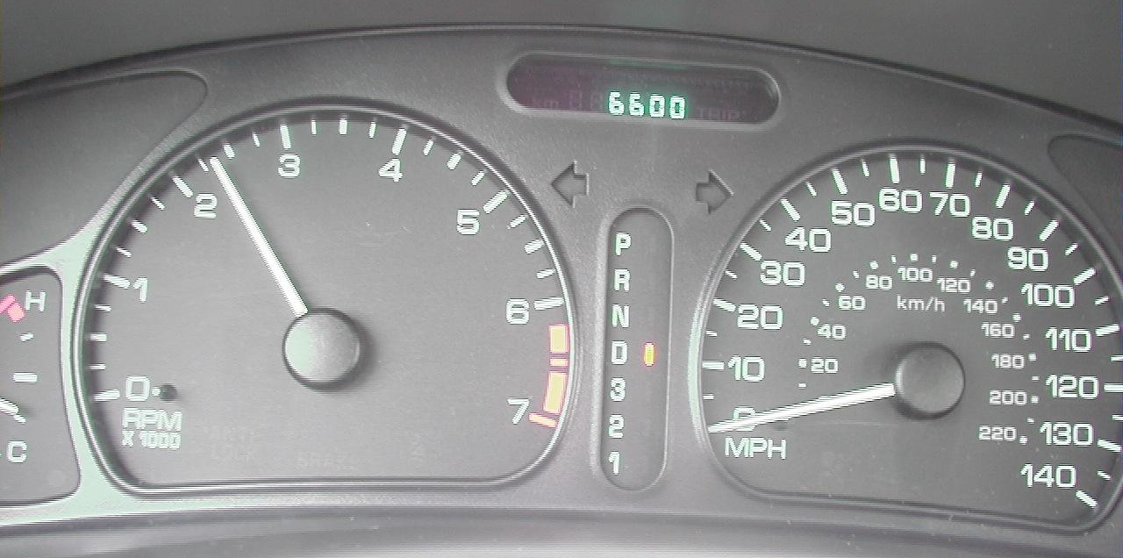
____________________________________________________________________

2. What is the specified engine speed during the stall test? _________________________
3. What is the recorded engine speed during the stall test? _________________________
4. Based on the test results, what is the needed action? _____________________________
____________________________________________________________________

