Name:_____________________________________
Date:_____________
Time on Task:_____________
Make/Model/Year:____________________________________
VIN:_________________________________
Evaluation (Enter number from 4, 3, 2, 1) :_________
Meets ASE Task: (A2-A-12) P-1 Perform pressure tests on transmissions/transaxles equipped with electronic pressure control; determine needed action.
Pressure Test Automatic Transmission
Page 426
1. Check service information and determine where the pressure taps are located, what the
pressure should read, and under what conditions.
a. Pressure tap mainline pressure (describe location) _________________________
______________________________________________________________
b. Pressure tap purpose and location (describe) ______________________________
______________________________________________________________
c. Pressure tap (describe purpose and location) ______________________________
______________________________________________________________
2. What should the pressure be and when? _______________________________________
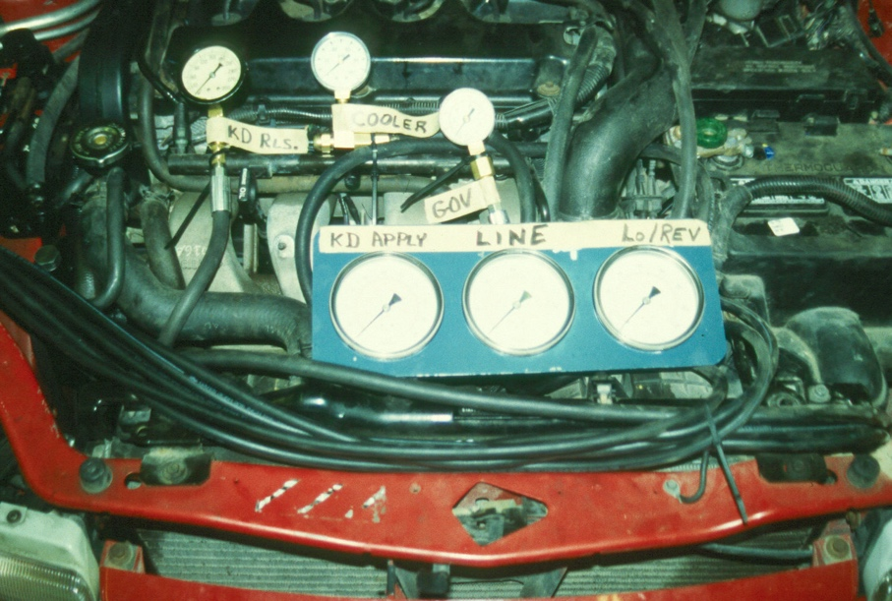

3. Based on the test results, what is the needed action? _____________________________
____________________________________________________________________

