Name:_____________________________________
Date:_____________
Time on Task:_____________
Make/Model/Year:____________________________________
VIN:_________________________________
Evaluation (Enter number from 4, 3, 2, 1) :_________
Meets ASE Task: (A2-A-4) P-1 Inspect transmission fluid condition; check fluid level; inspect for leaks on transmission or transaxle equipped with a dipstick. (A2-A-5) P-1 Inspect transmission fluid condition; check fluid level; inspect for leaks on transmission or transaxle not equipped with a dipstick. (A2-A-9) P-1 Diagnose fluid loss and condition concerns; determine needed action.
Diagnose Fluid Loss
Page 425

1. Check service information on the correct procedures to follow when checking the
automatic transmission fluid level (describe the procedure). _______________________
____________________________________________________________________
____________________________________________________________________
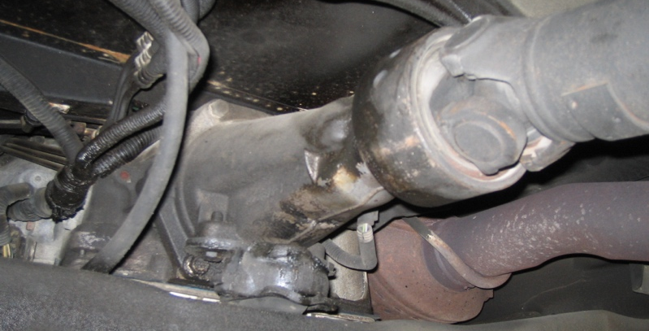

2. Check all that apply:
a. Transmission fluid level should be checked when cold.
b. Transmission fluid level should be checked when warm.
c. Has a fluid level dipstick.
d. Does not have a fluid level dipstick (describe how the fluid level is
determined) __________________________________________________
3. Type of automatic transmission fluid = ________________________________________
4. Any visible leaks? No Yes (If yes, describe) _________________________
____________________________________________________________________
5. Based on the inspection, what is the needed action? ______________________________

