Meets ASE Task: (A2-B-2) P-1 Drain and replace fluid and filter(s); use proper fluid type per manufacturer specification.

Evaluation (Enter number from 4, 3, 2, 1) :_________
Service Automatic Transmission/Transaxle
Name:_____________________________________
Date:_____________
Time on Task:_____________
Make/Model/Year:____________________________________
VIN:_________________________________
Page 424
1. Check service information for the recommended procedures to follow when servicing
the automatic transmission/transaxle. Describe the recommended procedures.
__________________________________________________________________
__________________________________________________________________
__________________________________________________________________
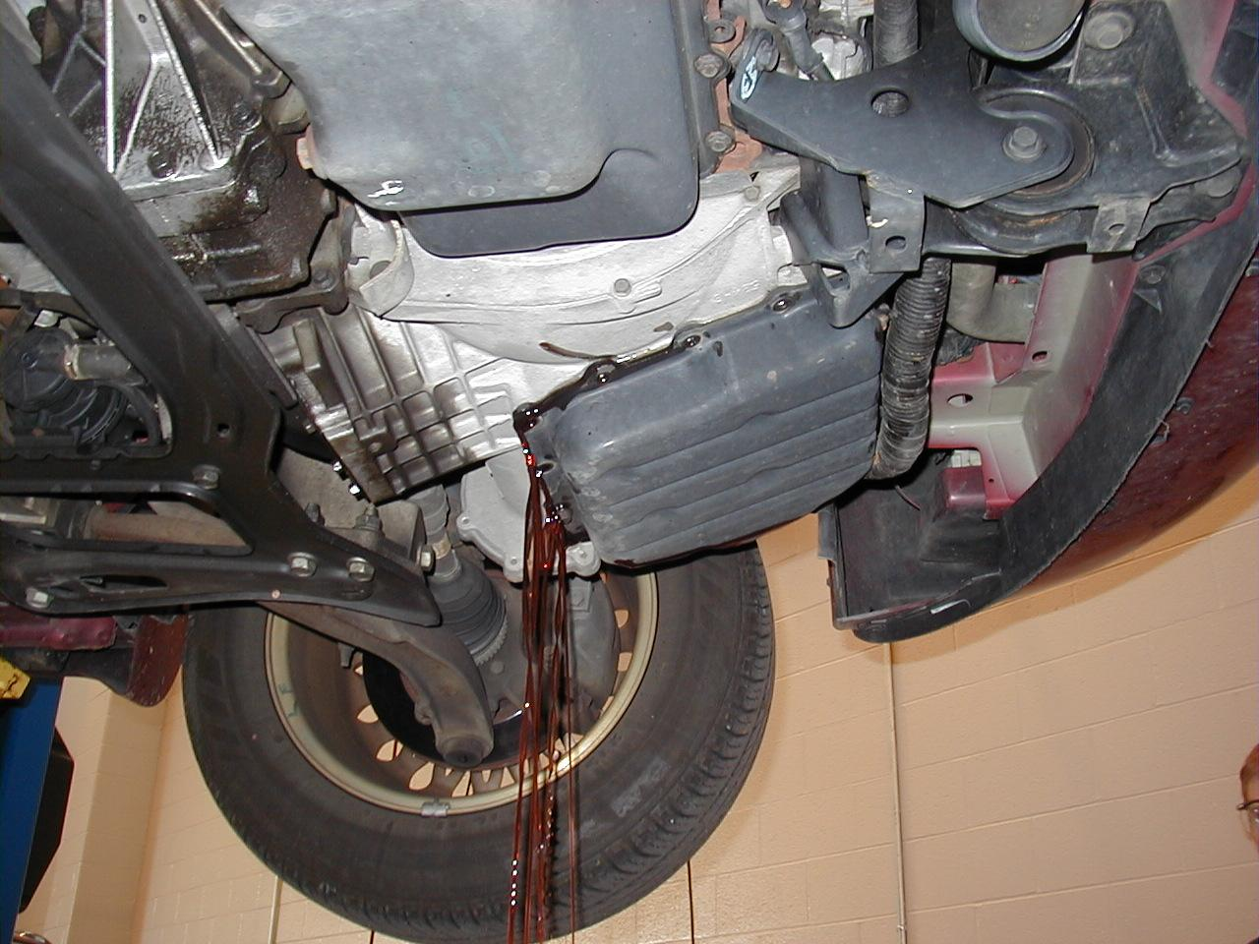

2. What is the recommended fluid? _____________________________________
3. How many quarts (liters) of fluid were used? ____________________________
4. What type of filter is used? (Describe) _________________________________
_____________________________________________________________

