Meets ASE Task: (A2-A-7) P-1 Demonstrate knowledge of/diagnose pressure concerns in a transmission using hydraulic principles (Pascal’s Law).
Evaluation (Enter number from 4, 3, 2, 1) :_________
Diagnose Hydraulic Pressure Concerns
Name:_____________________________________
Date:_____________
Time on Task:_____________
Make/Model/Year:____________________________________
VIN:_________________________________
Page 422
1. Describe the hydraulic pressure concern. ______________________________________
_______________________________________________________________________
_______________________________________________________________________
2. Check service information for the specified tests and procedures to follow to diagnose a
hydraulic pressure concern. ________________________________________________
____________________________________________________________________
____________________________________________________________________
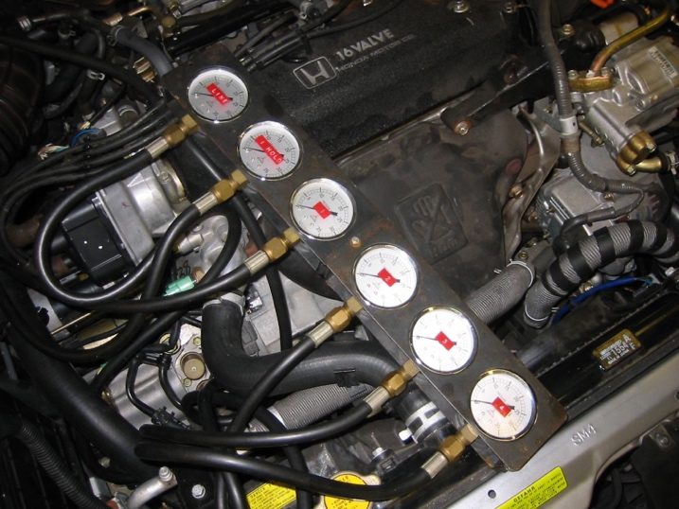

3. List the pressure measurements and compare them to the specifications.
Measured Specified
Main line pressure __________________ __________________
Low/reverse __________________ __________________
_______________ __________________ __________________
_______________ __________________ __________________

