Meets ASE Task: (A2-A-2) P-1 Identify automatic transmission and transaxle components and configurations.
Evaluation (Enter number from 4, 3, 2, 1) :_________
Identify Drivetrain Components
Name:_____________________________________
Date:_____________
Time on Task:_____________
Make/Model/Year:____________________________________
VIN:_________________________________
Page 421
1. What is the difference between an automatic transmission and an automatic transaxle?
Describe the differences. _________________________________________________
__________________________________________________________________
__________________________________________________________________
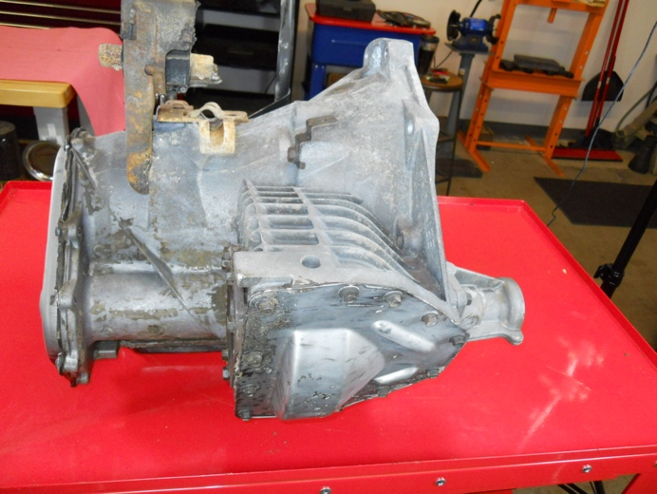
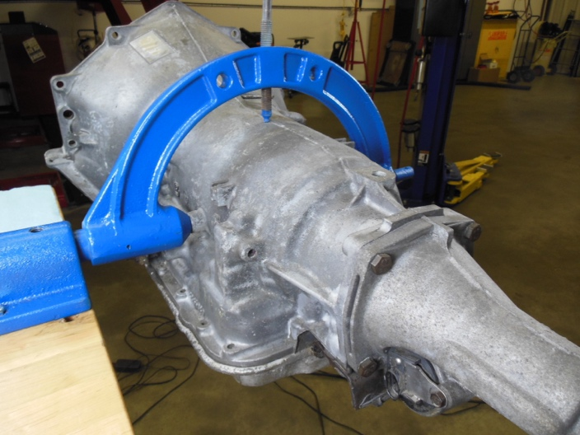

2. What components are the same between an automatic transmission and an automatic
transaxle? ____________________________________________________________
_________________________________________________________________
_________________________________________________________________
3. What components are difference between an automatic transmission and an automatic
transaxle? ____________________________________________________________
_________________________________________________________________
_________________________________________________________________

