Meets ASE Task: (A2-A-1) P-1 Research vehicle service information such as fluid type, vehicle service history, service precautions, technical service bulletins, and recalls including vehicles equipped with advanced driver assistance systems (ADAS).
Evaluation (Enter number from 4, 3, 2, 1) :_________
Automatic Transmission/Transaxle ID
Name:_____________________________________
Date:_____________
Time on Task:_____________
Make/Model/Year:____________________________________
VIN:_________________________________
Page 420
1. Check service information for the location of the identification numbers on the automatic
transmission/transaxle.
Location of ID numbers: _____________________________________________
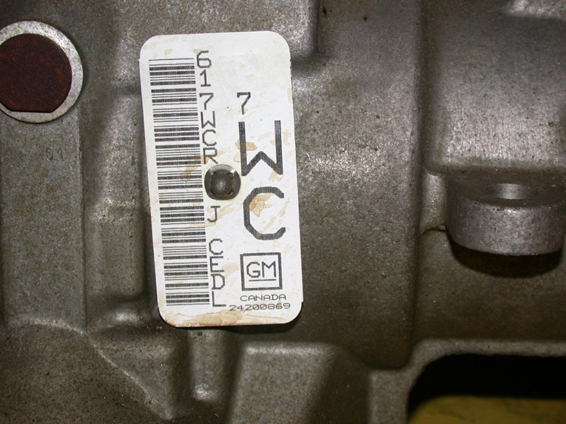
Transmission/transaxle ID: ___________________________________________

2. List the following information as determined by the identification label.
Model/type = __________________________
Date of manufacturer = _________________________
Assembly worker shift = ___________________________
Other (describe) __________________________________________________
__________________________________________________________

