Evaluation (Enter number from 4, 3, 2, 1) :_________
Meets ASE Task: (A1-A-8) P-2 Identify service precautions related to service of an internal combustion engine of a hybrid vehicle.

Hybrid Electric Vehicle Safety Precautions

Name:_____________________________________
Date:_____________
Time on Task:_____________
Make/Model/Year:____________________________________
VIN:_________________________________
Page 42
1. Check service information for the specified procedures to follow when servicing the
engine of a hybrid electric vehicle. Describe the specified precautions. __________
_____________________________________________________________________
2. Does the vehicle need to have the high-voltage disconnect removed before changing the engine oil?
Yes No
3. Check the location of the following:
High-voltage orange cables
High-voltage yellow or blue conduit wiring
High-voltage A/C compressor
High-voltage disconnect
Other (describe) _______________________________________________
4. Describe the location of the following:
High-voltage ____________________________________________________
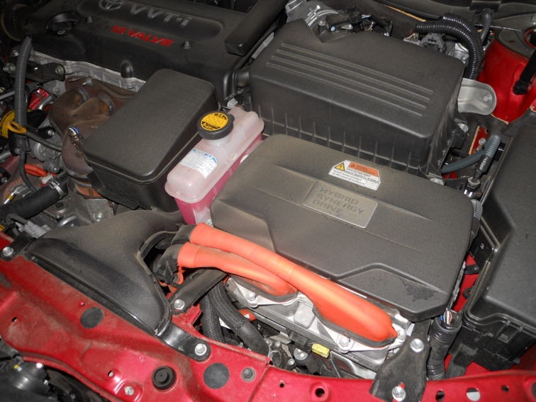
Orange cables ____________________________________________________

