Name:_____________________________________
Date:_____________
Time on Task:_____________
Make/Model/Year:____________________________________
VIN:_________________________________
Evaluation (Enter number from 4, 3, 2, 1) :_________
Meets ASE Task: : (A3-D-5) P-1 Diagnose universal joint noise and vibration concerns; determine needed action. (A4-F-9) P-1 Diagnose wheel/tire vibration, shimmy, and noise; determine needed action.

Noise and Vibration Diagnosis
Page 419
1. Check service information for the specified (if any) methods and procedures to follow
when diagnosing noise and/or vibration concerns.

__________________________________________________________________
__________________________________________________________________

2. Test drive the vehicle and verify the concerns. Check all that apply:

Noise Vibration Both

3. If there is a vibration, what frequency and at what speed is the vibration?

Frequency _________ Vehicle speed _________
Frequency _________ Vehicle speed _________
Frequency _________ Vehicle speed _________
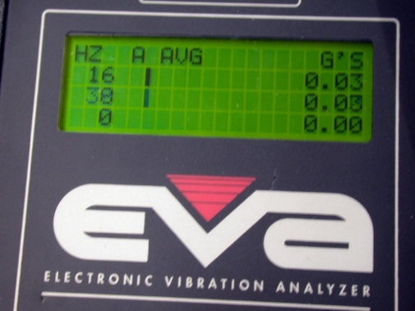
Frequency _________ Vehicle speed _________

4. If a noise, check for witness marks and describe this location: ___________________

__________________________________________________________________

5. Based on the test results and visual inspection, what is the needed action?

__________________________________________________________________

