Name:_____________________________________
Date:_____________
Time on Task:_____________
Make/Model/Year:____________________________________
VIN:_________________________________
Evaluation (Enter number from 4, 3, 2, 1) :_________
Meets ASE Task: : (A3-F-7) P-3 Disassemble, service, and reassemble transfer case and components.

Transfer Case Disassembly and Reassembly
Page 418
1. Check service information for the recommended procedures to follow when
disassembling and reassembling a transfer case. Describe the procedure. ____________
____________________________________________________________________
____________________________________________________________________
____________________________________________________________________
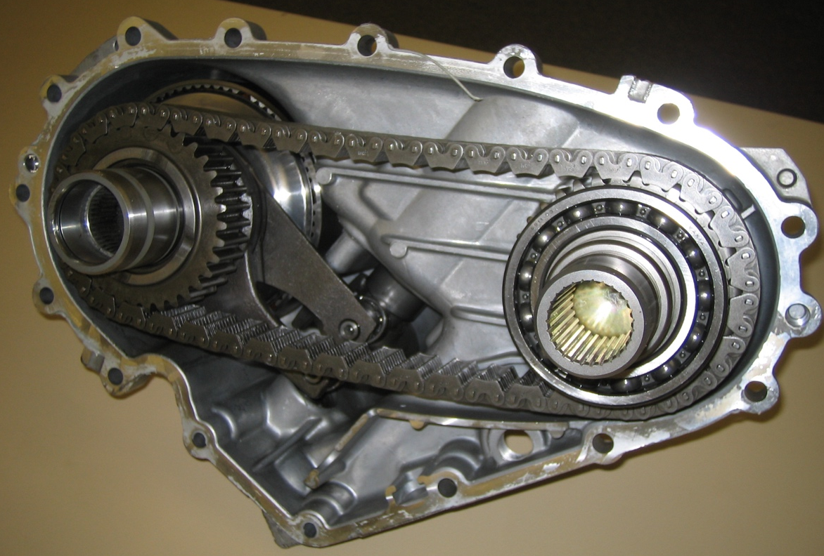

2. List the tools recommended to be used to disassemble and reassemble the transfer case.
____________________________________________________________________
____________________________________________________________________
3. List all faults or concerns found. ____________________________________________
____________________________________________________________________

