Name:_____________________________________
Date:_____________
Time on Task:_____________
Make/Model/Year:____________________________________
VIN:_________________________________
Evaluation (Enter number from 4, 3, 2, 1) :_________
Meets ASE Task: : (A3-F-6) P-2 Diagnose, test, adjust, and replace electrical/electronic components of four-wheel drive systems.
Transfer Case Electrical Components
Page 417
1. Check service information for the recommended procedures and test equipment needed
to test the electrical/electronic components of the four-wheel drive system. Describe
testing procedures. ______________________________________________________
____________________________________________________________________
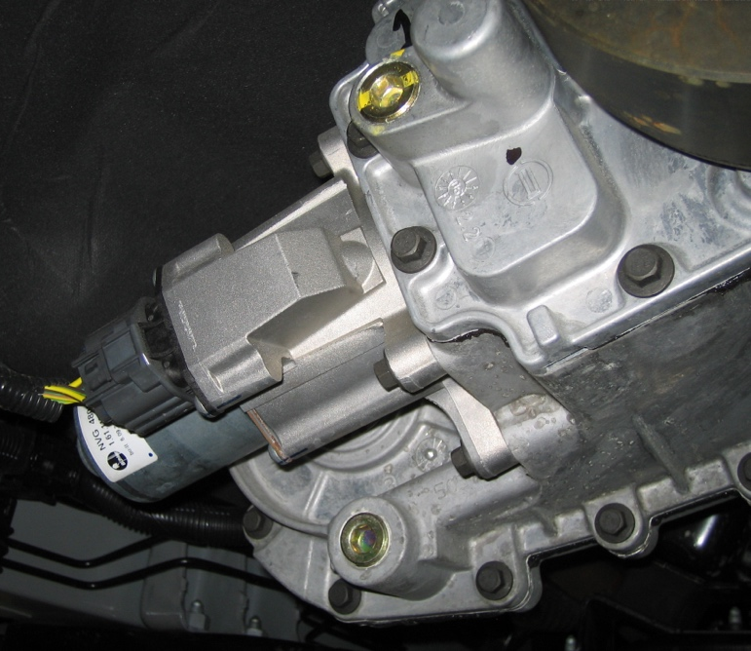
____________________________________________________________________

2. What specified test equipment is needed? Check all that apply.
DMM
Scan tool
Special tester (describe) ___________________________________________
Other (describe) _________________________________________________

