Name:_____________________________________
Date:_____________
Time on Task:_____________
Make/Model/Year:____________________________________
VIN:_________________________________
Evaluation (Enter number from 4, 3, 2, 1) :_________
Meets ASE Task: : (A3-F-4) P-3 Check for leaks at drive assembly and transfer case seals; check vents; check fluid level; use proper fluid type per manufacturer specification.
Four-Wheel Drive Fluid
Page 415
1. Check the service manual for correct fluid and for the location for inspecting the fluid.

Recommended fluid = __________________
Inspection location = _______________________
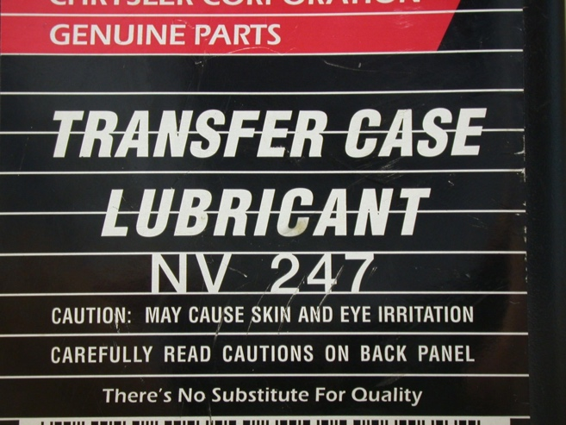
2. Hoist the vehicle safely.

3. Inspect the fluid level and replace as
required or recommended.

level okay
level low - added fluid
drained and replaced the fluid

4. Check the engine and transmission/transfer
case mounts.

all mounts are dry and okay
one or more of the mounts is oil soaked
one or more of the mounts is collapsed or defective
other (describe) _____________________________________

NOTE: A defective engine or transmission/transfer case mount can cause abnormal vibrations and noise.

