Name:_____________________________________
Date:_____________
Time on Task:_____________
Make/Model/Year:____________________________________
VIN:_________________________________
Evaluation (Enter number from 4, 3, 2, 1) :_________
Meets ASE Task: : (A3-F-4) P-3 Check for leaks at drive assembly and transfer case seals; check vents; check fluid level; use proper fluid type per manufacturer specification.
Transfer Case Lube Level Check
Page 414
1. Check service information for the specified methods to follow to check the seals, vents,
and lube level (describe). __________________________________________________
____________________________________________________________________
____________________________________________________________________
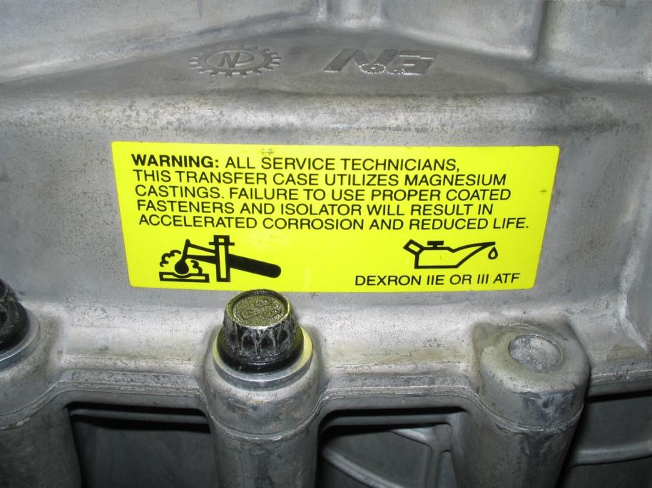
____________________________________________________________________

2. What is the specified lube? ___________________________________
3. Were the vents clear? Yes No If no, describe why they were clogged.
____________________________________________________________________
____________________________________________________________________
4. Were the seals okay? Yes No If no, describe which seals were leaking.
____________________________________________________________________
____________________________________________________________________

