Name:_____________________________________
Date:_____________
Time on Task:_____________
Make/Model/Year:____________________________________
VIN:_________________________________
Evaluation (Enter number from 4, 3, 2, 1) :_________
Meets ASE Task: : (A3-F-3) P-3 Inspect axle locking mechanisms; determine needed action(s).
Inspect Front Locking Hubs
Page 413
1. Check service information for the recommended procedures to follow when inspecting
front bearings and locking hubs. Describe the inspection procedures. _______________
____________________________________________________________________
____________________________________________________________________
____________________________________________________________________
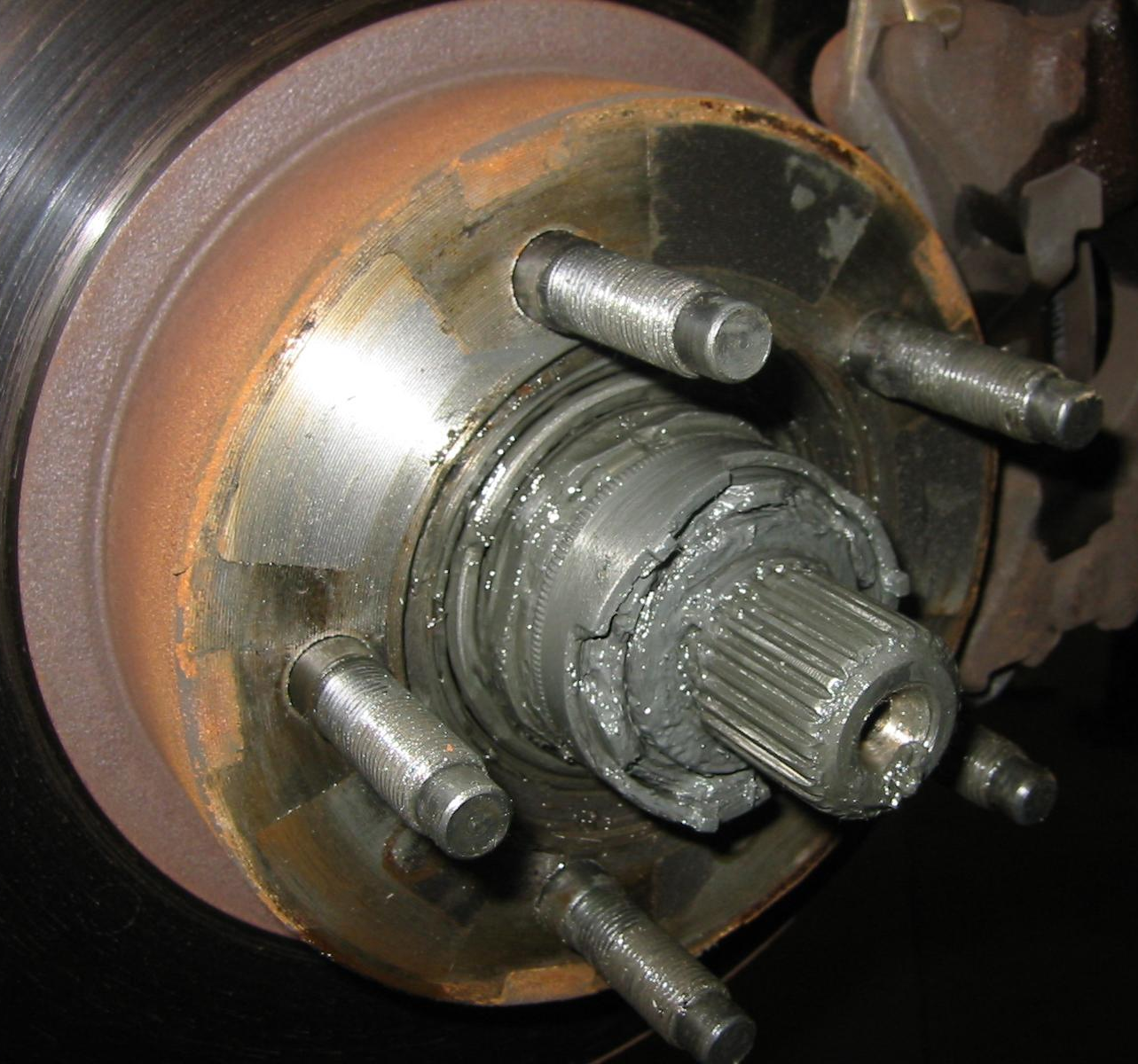

2. Based on the inspection, what is the needed action? _____________________________
___________________________________________________________________
___________________________________________________________________
___________________________________________________________________

