Name:_____________________________________
Date:_____________
Time on Task:_____________
Make/Model/Year:____________________________________
VIN:_________________________________
Evaluation (Enter number from 4, 3, 2, 1) :_________
Meets ASE Task: : (A3-F-2) P-2 Inspect, adjust, and repair shifting controls (mechanical, electrical, and vacuum), bushings, mounts, levers, and brackets.

Inspect and Adjust Shifting Controls
Page 412
1. Check service for the specified procedure to follow when inspecting, adjusting, or
repairing shift controls of the four-wheel drive transfer case. Describe the specified
procedure: ______________________________________________________________
____________________________________________________________________
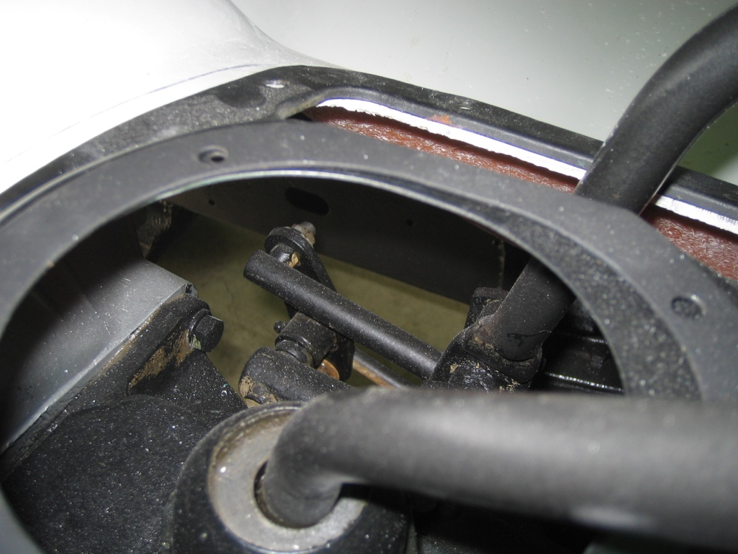

2. Describe the type of controls used. Check all that apply.
Mechanical rods/bushings
Electrical
Vacuum
Other (describe) _____________________________________________
__________________________________________________________

