Name:_____________________________________
Date:_____________
Time on Task:_____________
Make/Model/Year:____________________________________
VIN:_________________________________
Evaluation (Enter number from 4, 3, 2, 1) :_________
Meets ASE Task: : (A3-E.3-2) P-3 Measure rotating torque; determine needed action.

Limited Slip Differential Rotating Torque
Page 411
1. Check service information for the recommended procedures to be followed when
checking for rotating torque of a limited slip differential. Describe the procedures. ___
____________________________________________________________________
____________________________________________________________________
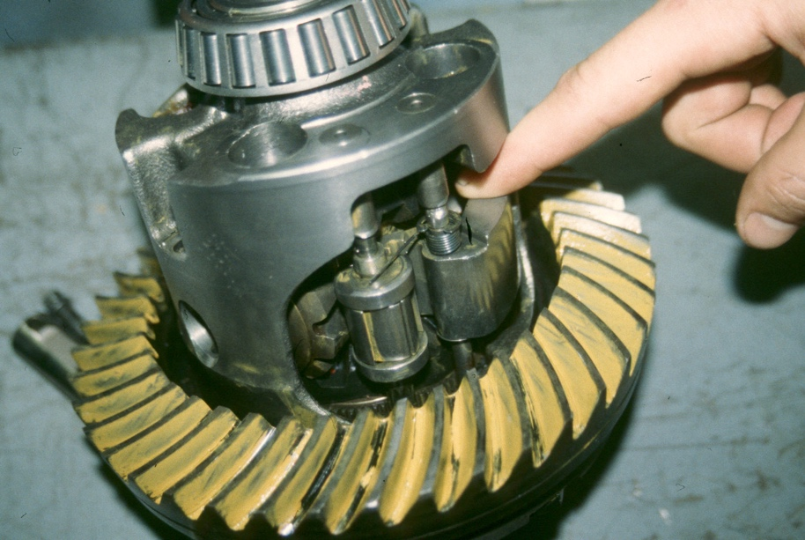
____________________________________________________________________

2. What is the specified limited slip slippage torque? _____________________________
3. What was the actual measured rotating torque? _____________________________
4. Based on the test results, what is the needed action? _____________________________
____________________________________________________________________
____________________________________________________________________
____________________________________________________________________

