Name:_____________________________________
Date:_____________
Time on Task:_____________
Make/Model/Year:____________________________________
VIN:_________________________________
Evaluation (Enter number from 4, 3, 2, 1) :_________
Meets ASE Task: : (A3-E.3-1) P-3 Diagnose noise, slippage, and chatter concerns; determine needed action.

Limited Slip Differential Diagnosis
Page 410
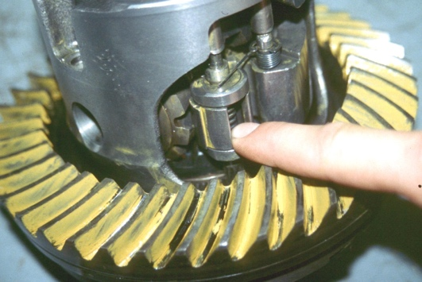
_____ 1. Check the type of limited slip differential.
_____ Cone-type
_____ Viscous coupling
_____ Eaton locker
_____ Torsen (torque sensing)
_____ Other (describe) ___________________________________________
_____ 2. Using service information, determine the testing procedure for checking the proper
operation of the differential. Describe the testing procedure and list the tools or
equipment needed.
__________________________________________________________________
__________________________________________________________________
__________________________________________________________________
__________________________________________________________________
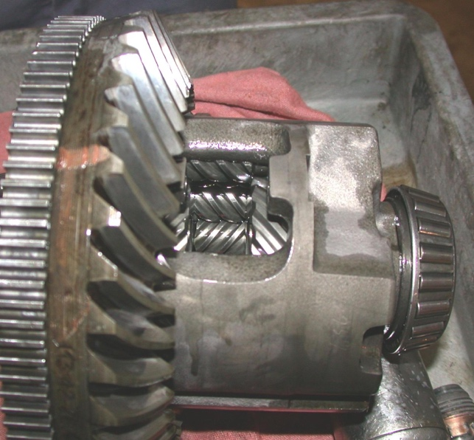
_____ 3. Perform the function test procedure.
OK _____ NOT OK _____
____ 4. Based on the inspection and test results,
what is the needed action?
_______________________________
_______________________________

