Name:_____________________________________
Date:_____________
Time on Task:_____________
Make/Model/Year:____________________________________
VIN:_________________________________
Evaluation (Enter number from 4, 3, 2, 1) :_________
Meets ASE Task: : (A3-E.1-13) P-2 Reassemble and reinstall differential case assembly; measure runout; determine needed action.
Differential Case Assembly
Page 409
1. Check service information for the specified procedures for installing the differential case
assembly and measure ring gear runout. Describe the specified procedures. __________
____________________________________________________________________
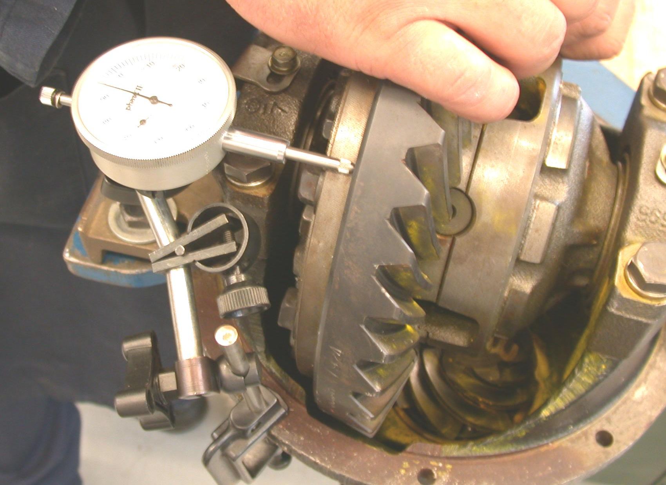
____________________________________________________________________

2. What is the specified runout? ________________________________________
3. What is the measured runout? ________________________________________
4. Based on the inspection and runout measurement, what is the needed action?
___________________________________________________________________
___________________________________________________________________
___________________________________________________________________

