Name:_____________________________________
Date:_____________
Time on Task:_____________
Make/Model/Year:____________________________________
VIN:_________________________________
Evaluation (Enter number from 4, 3, 2, 1) :_________
Meets ASE Task: : (A3-E.1-12) P-2 Disassemble, inspect, measure, adjust and/or replace differential pinion gears (spiders), shaft, side gears, side bearings, thrust washers, and case.
Differential Pinion Gears and Case
Page 408
1. Check service information for the specified procedures to follow for disassembly,
inspection, and reassembly of the differential pinion gears, side bearing, and case.
Describe the specified procedure. ____________________________________________
____________________________________________________________________
____________________________________________________________________
____________________________________________________________________
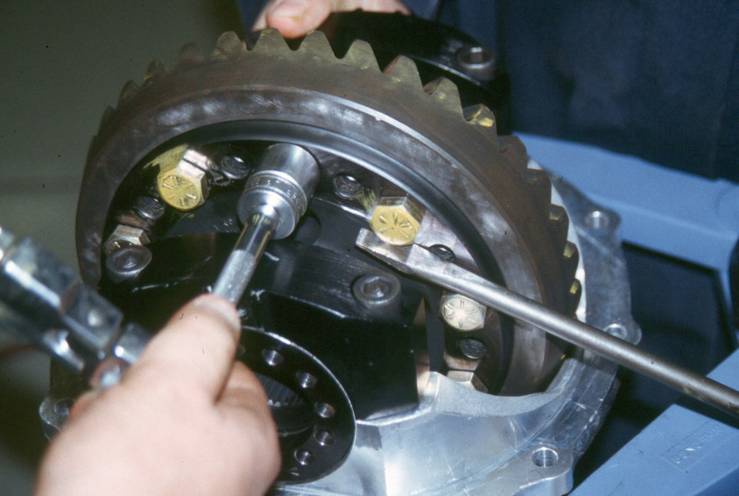

2. What are the torque specifications?
Ring gear to case _________________
Side bearing caps _________________
Pinion gear retaining bolts (if applicable) __________________
Other (specify) ______________________________________________________

