Name:_____________________________________
Date:_____________
Time on Task:_____________
Make/Model/Year:____________________________________
VIN:_________________________________
Evaluation (Enter number from 4, 3, 2, 1) :_________
Meets ASE Task: : (A3-E.1-11) P-2 Check ring and pinion tooth contact patterns; perform needed action.
Ring and Pinion Tooth Pattern
Page 407
1. Check service information and determine the specified procedures to follow when
performing a ring and pinion gear tooth pattern contact procedure. Describe the specified
procedure. ______________________________________________________________
____________________________________________________________________
____________________________________________________________________
____________________________________________________________________
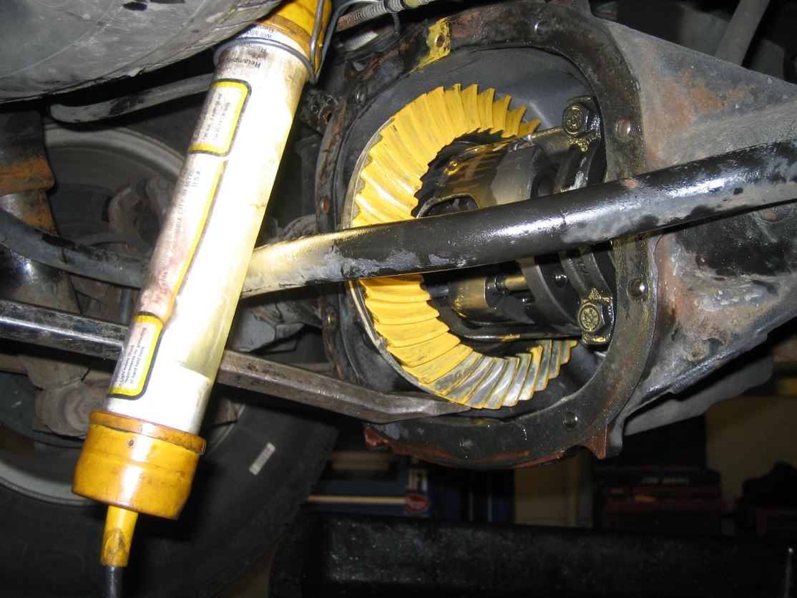

2. Based on the results of the tooth contact pattern, what is the needed action? __________
____________________________________________________________________
____________________________________________________________________

