Name:_____________________________________
Date:_____________
Time on Task:_____________
Make/Model/Year:____________________________________
VIN:_________________________________
Evaluation (Enter number from 4, 3, 2, 1) :_________
Meets ASE Task: : (A3-E.1-10) P-2 Measure and adjust side bearing preload and ring and pinion gear total backlash and backlash variation on a differential carrier assembly (threaded cup or shim types).
Differential Side Bearing Preload
Page 406
1. Check service information and determine the specified procedure to follow to adjust side
bearing preload. Describe the procedure. _____________________________________
____________________________________________________________________
____________________________________________________________________
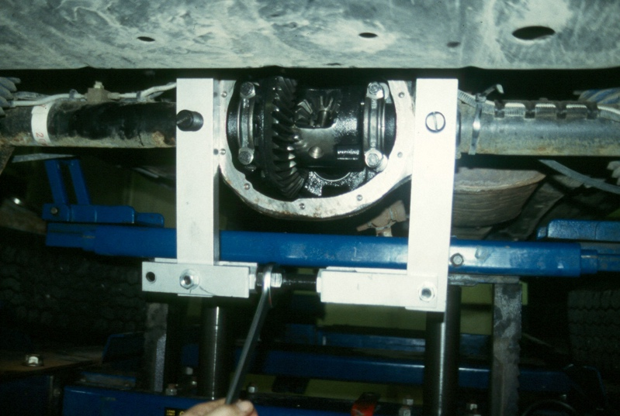
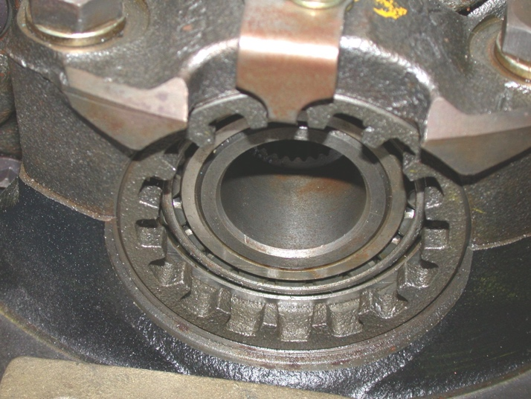
____________________________________________________________________

2. Which type of differential is being serviced?
Shim type
Threaded cap

