Name:_____________________________________
Date:_____________
Time on Task:_____________
Make/Model/Year:____________________________________
VIN:_________________________________
Evaluation (Enter number from 4, 3, 2, 1) :_________
Meets ASE Task: : (A3-E.1-9) P-2 Measure and adjust drive pinion preload.
Drive Pinion Bearing Preload
Page 405
1. Check service information and determine the specified procedures to follow for
measuring and adjusting drive pinion preload. Describe the procedures and
specifications. _________________________________________________________
___________________________________________________________________
____________________________________________________________________
____________________________________________________________________
____________________________________________________________________
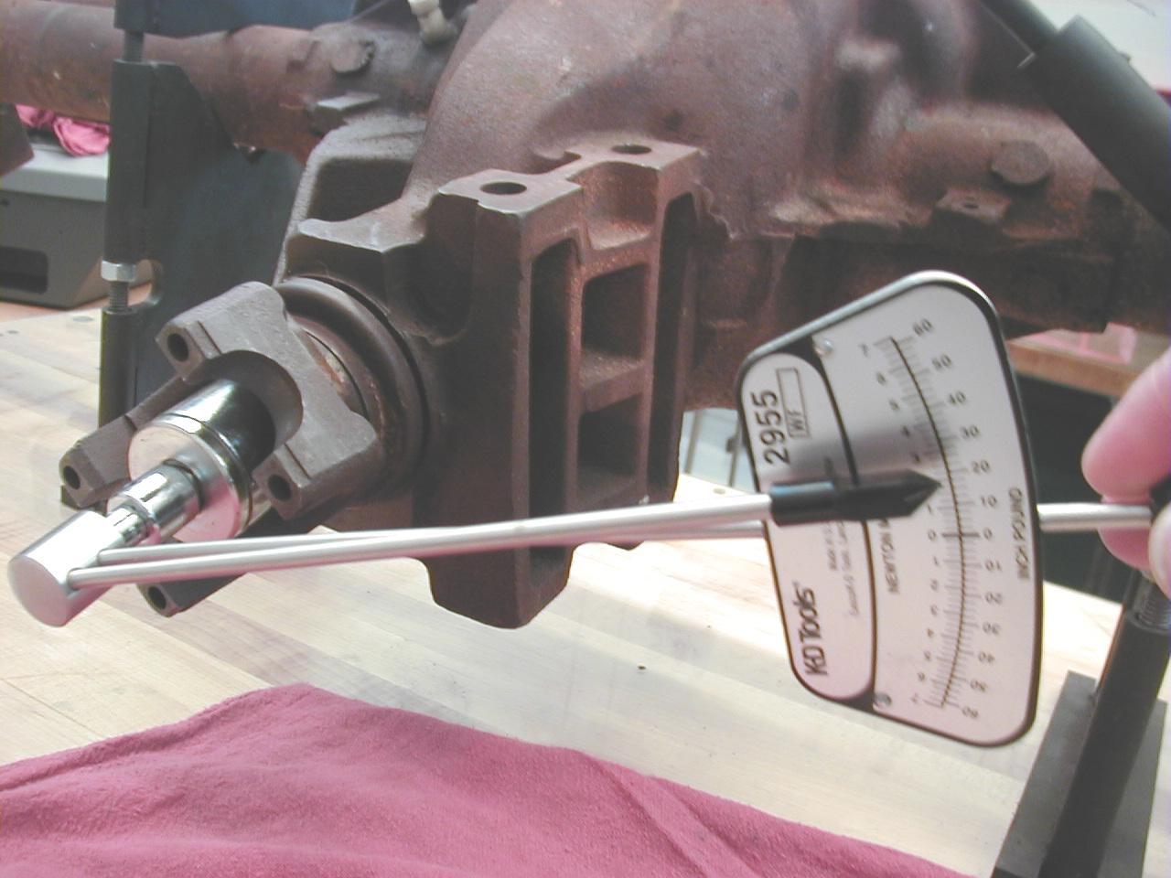

2. What is the rotating torque specification? ____________________________

