Name:_____________________________________

Date:_____________

Time on Task:_____________

Make/Model/Year:____________________________________

VIN:_________________________________

Evaluation (Enter number from 4, 3, 2, 1) :_________

**Meets ASE Task: :** (A3-E.1-8) P-2 Measure and adjust drive pinion depth.

**Drive Pinion Depth**

Page 404

**1.** Check service information for the specified procedures and drive pinion depth

measurement. Describe the measuring procedure. ______________________________

____________________________________________________________________

____________________________________________________________________

____________________________________________________________________

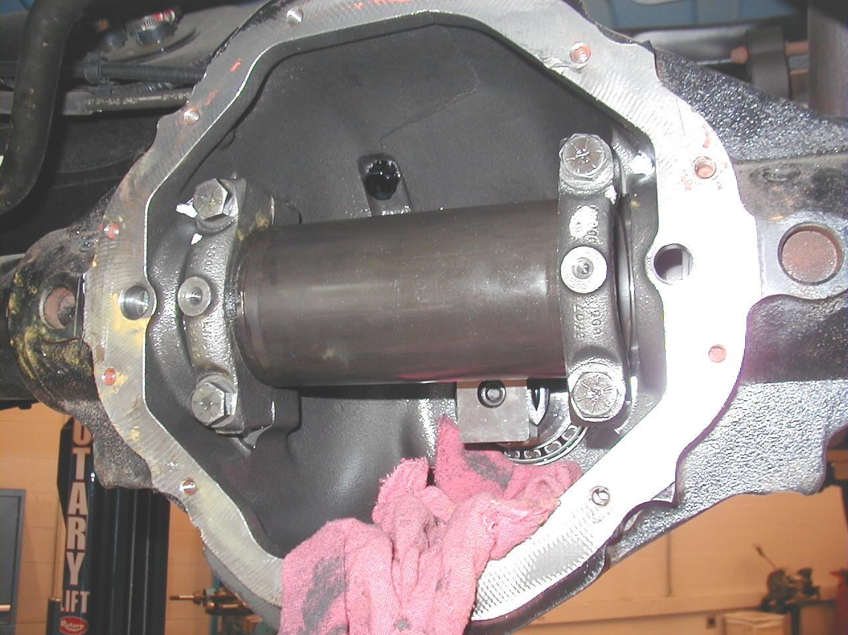

**2.** Check service information and determine the specified pinion depth. _______________

___________________________________________________________________

**3.** Check service information to determine what mark(s) on the pinion mean. ___________

____________________________________________________________________