Name:_____________________________________

Date:_____________

Time on Task:_____________

Make/Model/Year:____________________________________

VIN:_________________________________

Evaluation (Enter number from 4, 3, 2, 1) :_________

**Meets ASE Task: :** (A3-E.1-7) P-2 Remove, inspect, reinstall and/or replace drive pinion and ring gear, spacers, sleeves, and bearings.

**Differential Assembly Inspection**

Page 403

**1.** Check service information and determine the specified procedure to follow for the

removal and reinstallation of the ring gear, drive pinion, and bearings. Describe the

procedure.

____________________________________________________________________

____________________________________________________________________

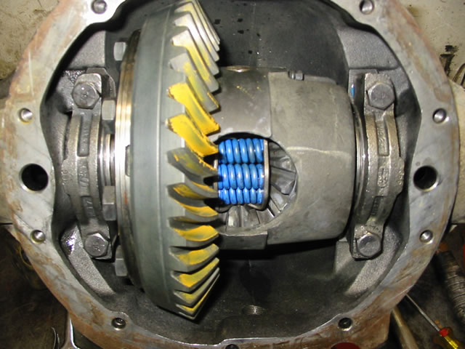 ____________________________________________________________________

**2.** Check service information and determine the torque specifications for the following:

Cover ______________

Ring gear bolts ______________

Side bearing caps _______________

Other (describe) ____________________________________________________