Name:_____________________________________
Date:_____________
Time on Task:_____________
Make/Model/Year:____________________________________
VIN:_________________________________
Evaluation (Enter number from 4, 3, 2, 1) :_________
Meets ASE Task: : (A3-E.1-5) P-2 Inspect ring gear and measure runout; determine needed action.
Ring Gear Runout
Page 402
1. Check service information for specified methods to use to measure ring gear runout.
Describe the procedure. ___________________________________________________
____________________________________________________________________
____________________________________________________________________
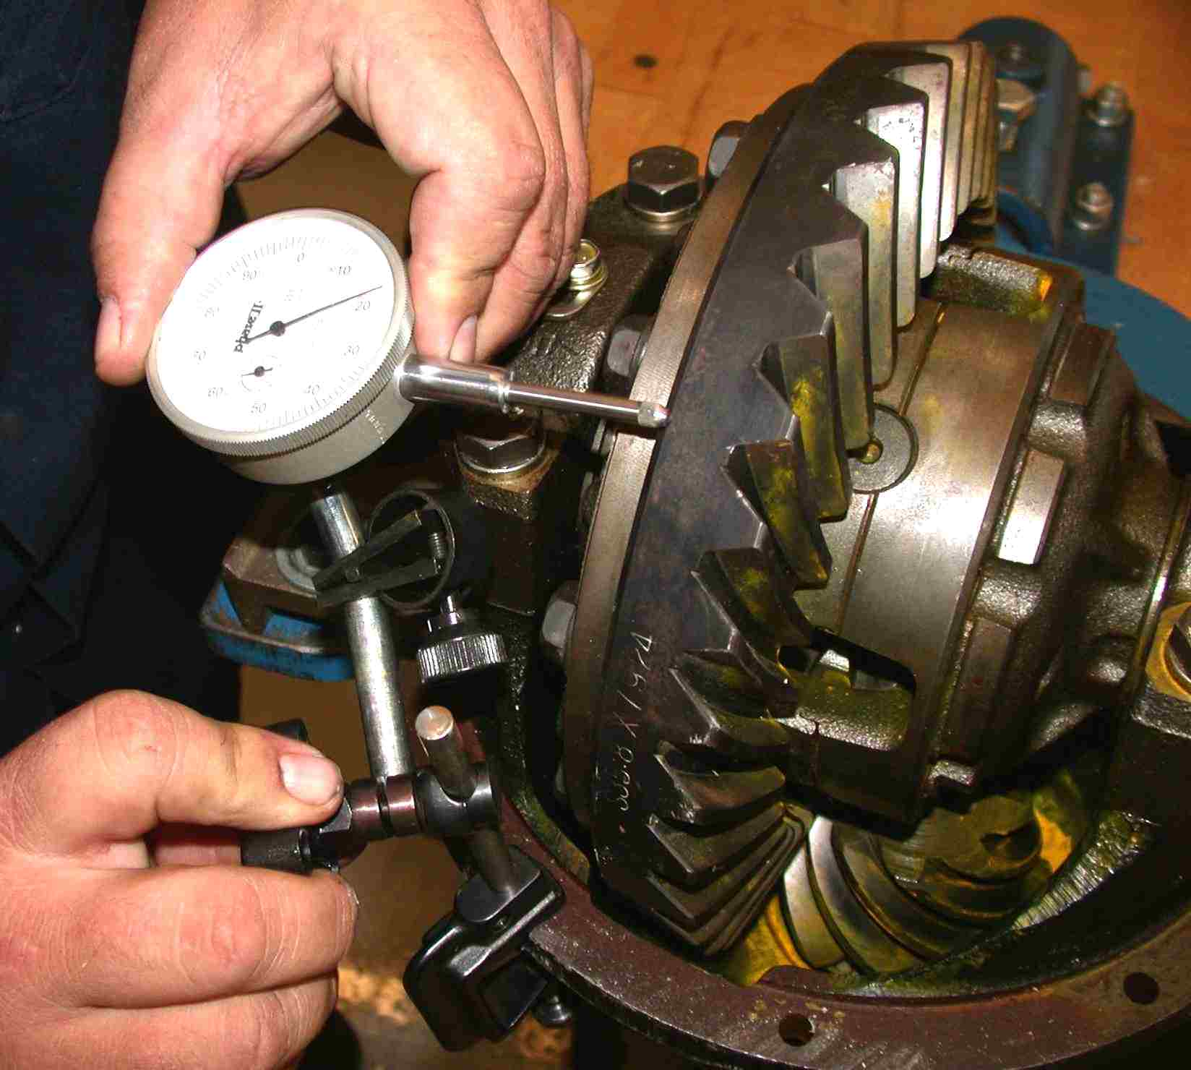
____________________________________________________________________

2. Ring gear runout specification = ________________________
3. Measured ring gear runout = ________________________
OK NOT OK
4. Based on the test results, what is the needed action? _____________________________
____________________________________________________________________
____________________________________________________________________

