Name:_____________________________________
Date:_____________
Time on Task:_____________
Make/Model/Year:____________________________________
VIN:_________________________________
Evaluation (Enter number from 4, 3, 2, 1) :_________
Meets ASE Task: : (A3-E.1-4) P-2 Inspect and replace companion flange and/or pinion seal; measure companion flange runout.
Pinion Seal Replacement
Page 401
1. Check service information for the exact procedures and specifications needed to perform
a pinion seal replacement. Describe the procedure. _____________________________
____________________________________________________________________
____________________________________________________________________
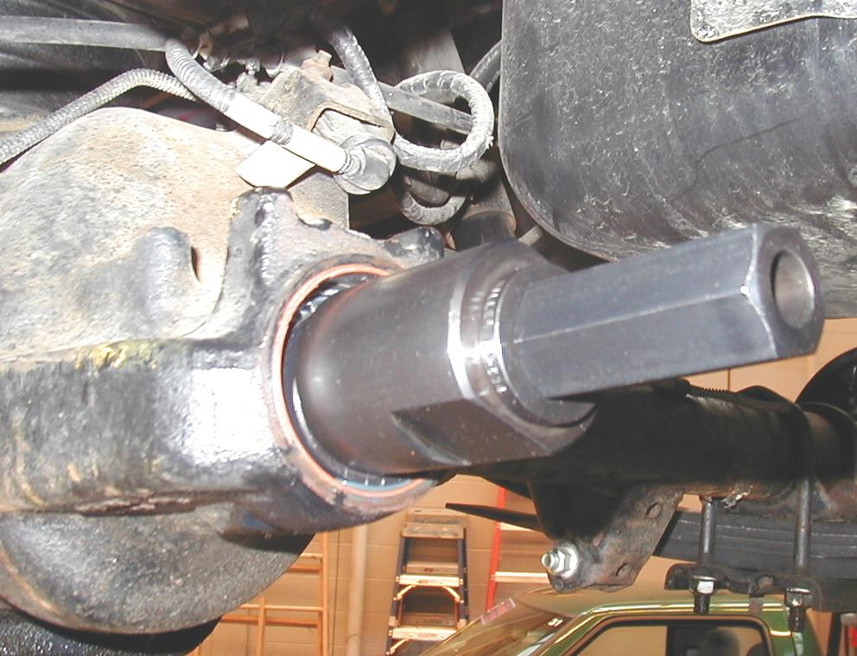
____________________________________________________________________

2. Measure the companion flange runout following the vehicle manufacturer’s
recommended procedures.
Runout specification ____________________
Measured companion flange runout ___________________
OK NOT OK

