Name:_____________________________________
Date:_____________
Time on Task:_____________
Make/Model/Year:____________________________________
VIN:_________________________________
Evaluation (Enter number from 4, 3, 2, 1) :_________
Meets ASE Task: : (A3-E.1-1) P-1 Inspect differential housing; check for leaks; inspect housing vent.

Drive Axle Fluid Leaks
Page 400
1. Check service information for the specified method to use to diagnose drive axle fluid
leakage (describe the procedure). ____________________________________________
____________________________________________________________________
____________________________________________________________________
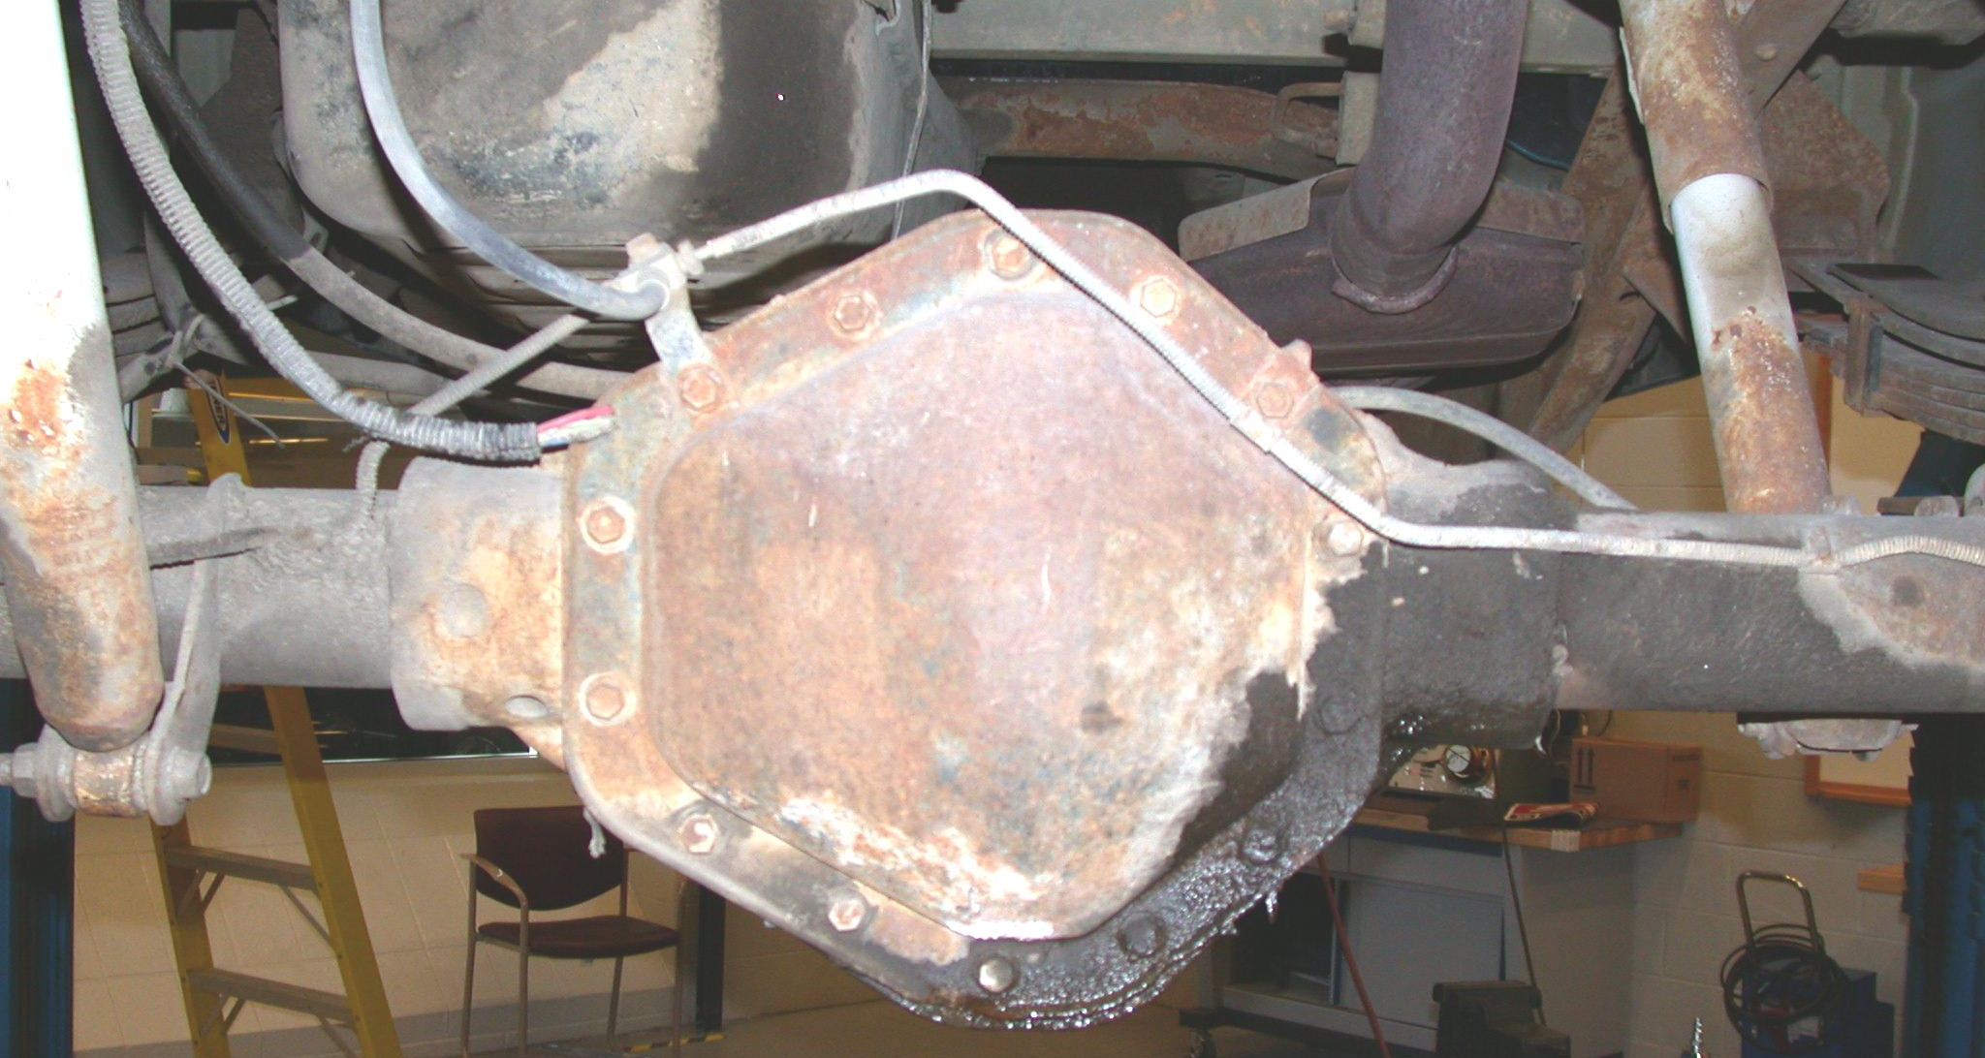

2. Where is the leakage detected? Check all that apply.
Cover
Pinion seal
Housing
Other (describe) _________________________________________________
3. Based on the inspection, what is the needed action? _____________________________
____________________________________________________________________
____________________________________________________________________

