Name:_____________________________________
Date:_____________
Time on Task:_____________
Make/Model/Year:____________________________________
VIN:_________________________________
Evaluation (Enter number from 4, 3, 2, 1) :_________
Meets ASE Task: : (A3-E.1-6) P-2 Diagnose noise and vibration concerns; determine needed action. (A3-F-5) P-2 Diagnose noise, vibration, and unusual steering concerns; determine needed action.

Differential Noise Diagnosis
Page 399
1. Check service information for the exact procedures to follow to determine the cause of a
vibration or noise concern in the differential assembly or transfer case (describe the test procedures).
____________________________________________________________________
____________________________________________________________________
____________________________________________________________________
____________________________________________________________________
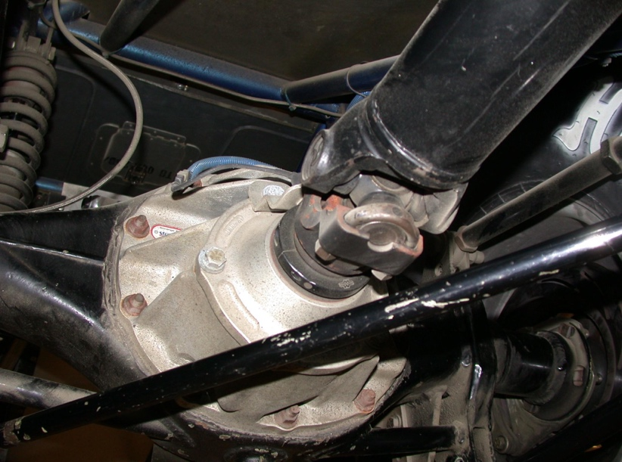

2. Based on the test results, what is the needed action? _____________________________
____________________________________________________________________
____________________________________________________________________

