Name:_____________________________________
Date:_____________
Time on Task:_____________
Make/Model/Year:____________________________________
VIN:_________________________________
Evaluation (Enter number from 4, 3, 2, 1) :_________
Meets ASE Task: : (A3-E.1-2) P-1 Check and adjust differential case fluid level; use proper fluid type per manufacturer specification.

Differential Fluid Check
Page 398
1. Check service information for the correct lubricant to use.
Specified lubricant = _______________________________
Amount of lubricant to fill the differential = _____________________________
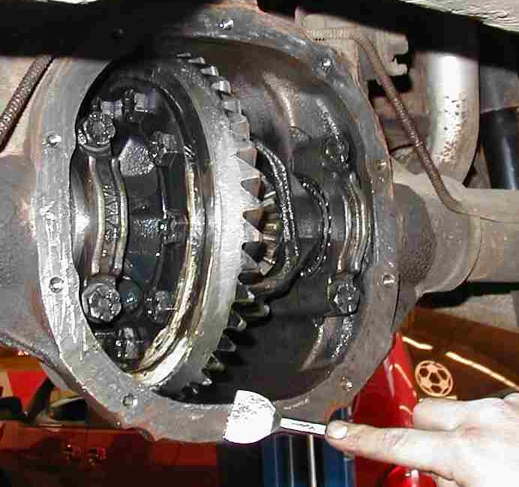
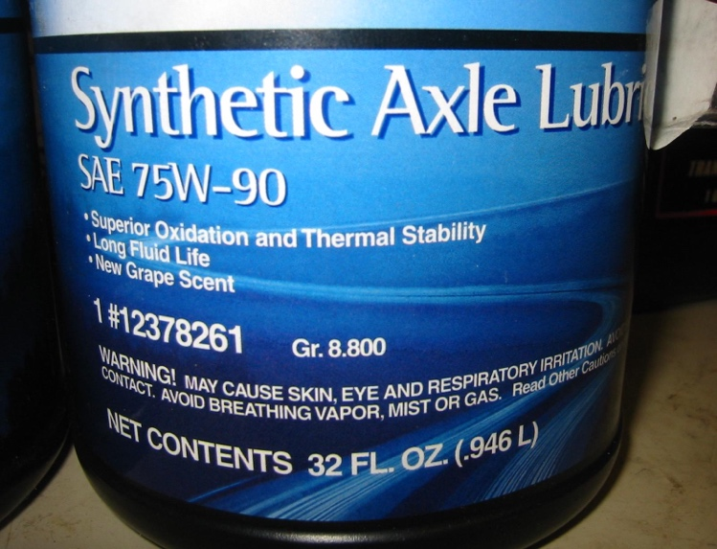

2. Hoist the vehicle safely.
3. Visually check for any signs of leakage.
OK Not OK (describe) __________________________________________
4. Remove the inspection plug from the side or rear cover of the drive axle.
5. Using a finger or a fabricated dipstick, measure the fluid level.
6. Record the results.
Level OK
Level was low, added fluid
Level was too high, allowed to drain excess

